Project information
CALL FOR PROPOSALS | 2
MIS-ETC: | 1330
PRIORITY AXIS: | 1.Economic and Social Development
MEASURE: | 1.2 Develop the tourism sector, including the strengthening of the regional identity of the border region as a tourist destination
PROJECT TITLE: | Development Of Cross-Border Activities In Cultural And Sports Field
ACRONYM: | DCBAFCS
DURATION: | 30.11.2012 – 29.04.2014
IPA FUNDS CONTRACTED: | 1.220.132,50 €
TOTAL FUNDS CONTRACTED: | 1.435.450,00 €
ABSORBTION RATE (%): | 89,79%

PROJECT OBJECTIVE(S): | The main objective of the project was to improve the quality of life for the people living in Drobeta Turnu Severin (Romania) and Negotin Town (Serbia).  Through the project, the partners succeeded to create a Cultural exhibition area with a layout of 730 sqm and created an amphitheatre area layout and a mobile scene layout in Negotin Town. In Crihala Forest in Drobeta Turnu Severin there were rehabilitated the pedestrian sidewalks and created sports fields covering an area of 3489.11 square meters and two playgrounds fields of 290,54 square meters in Negotin City.

SHORT DESCRIPTION OF THE PROJECT: | The project helped to create the necessary infrastructure to develop an integrated cross-border recreational and entertainment centre, to create basics for cross-border tourism development by organizing specific events related to both Serbian and Romanian culture and creating a centre to promote and support tourism.  This centre was created in the Crihala Forest Park in Drobeta Turnu Severin where now various events are being organized by the Turnu Severin City Hall and where the Serbian neighbours annually participate as guests. The Crihala Park was revitalized and now has a cultural exhibition area – where exhibitions are held; an Amphitheatre area for festivals and folkloric events, sport fields for tennis, basketball and football and Sport club. Negotin Municipality procured a mobile scene in Negotin City which is being used in the local events in the City main square, and also reconstructed two playgrounds which are also used for competitions and events between the two countries.

DEGREE OF ACHIEVEMENT OF INDICATORS: | Indicator Indicator value provisioned in the contract Present indicator value % 6 = (5)/(3)*100  Output indicators (1) UM (2) Quantity (3) UM (4) Quantity (5)  Increase of the number of new touring products  Increase the number of events organized by the two communities together  Result indicators  The number of cross-border tourism services (no. of promotional materials + events) No. 3852 (promotional materials) + 1 (event) No. 3852 (promotional materials) + 1 (event) 100%  Project indicator  Achieving the objectives set in Crihala Forest and Negotin City Square meters 24.670,01 Square meters 24.670,01 100%

RESULTS ACHIEVED: | Creation of 730 sqm of cultural exhibition area;  Creation of an Amphitheater area – 525.53 sqm;  Creation of 3489 sqm of sports dedicated area;  Creation of 19506 sqm of recreation driveways and side alleys;  Creation of 290.56 sqm of children playground;

Partnership information
 |  | COUNTRY | COUNTY/DISTRICT | BUDGET(EURO) | CONTACT DETAILS
LEAD PARTNER: | Drobeta Turnu Severin  City Hall | Romania | Mehedinți | 1.290.053,00 | Maresal Averescu Street, nr. 2, Drobeta Turnu Severin  Tel. +40252314379
PARTNER 2: | Negotin  City Hall | Serbia | Bor | 145.397,00 | NEGOTIN, Trg Stevana Mokranjca 1  Tel. +38119544000

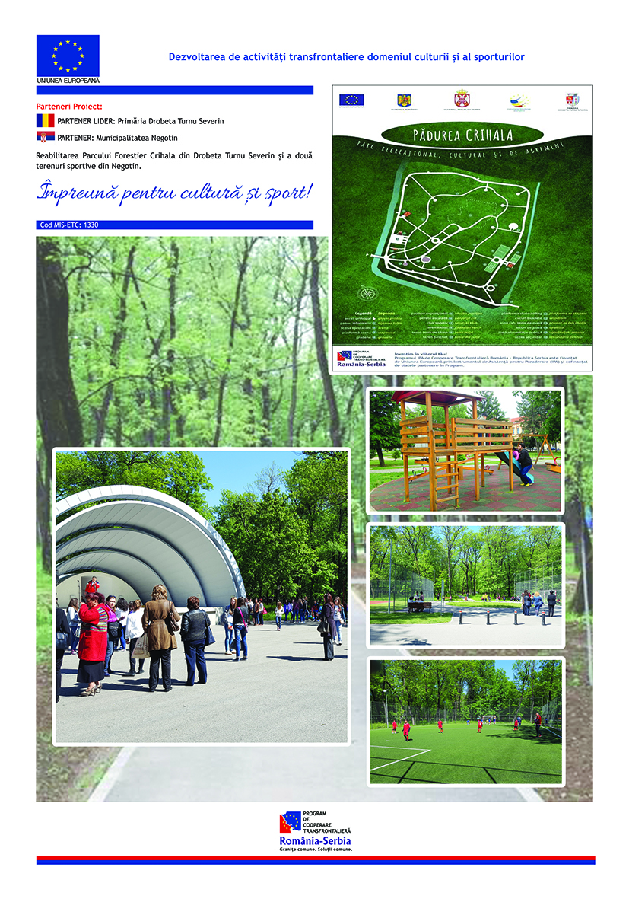

the implementation period (including extensions)
total funds spent/total funds contracted *100
indicators and level of achievement against targets set

