Project information
CALL FOR PROPOSALS | 2
MIS-ETC: | 1329
PRIORITY AXIS: | 1.Economic and Social Development
MEASURE: | 1.2 Develop the tourism sector, including the strengthening of the regional identity of the border region as a tourist destination
PROJECT TITLE: | Promoting tourist attractions in border areas Drobeta
ACRONYM: | PTABAD
DURATION: | 12.06.2013 – 11.06.2014
IPA FUNDS CONTRACTED: | 260.287,00
TOTAL FUNDS CONTRACTED: | 306.220,00
ABSORBTION RATE (%): | 85,09
PROJECT OBJECTIVE(S): | To achieve on the basis of joint cross-border projects and common actions by Romanian and Serbian stakeholders a more balanced and sustainable socio-economic development of the Romania-Serbian border area.  To promote a brand and a genuine sustainable tourism product specific to the border area.
SHORT DESCRIPTION OF THE PROJECT: | Inventory of the main forms of tourism practiced in the border cities of Drobeta Turnu Severin (Romania) and Negotin (Serbia) was achieved through this project. Seminars and tourist workshops were organized in order to promote tourism, DVD documentary film highlighting the attractiveness of tourism and in order to promote natural, historical and cultural border area was created. 750 Travel catalogues, 750 Travel guides, 600 Colour photos, 600 Flyers, 110 Polyurethane panels, 9 advertising TV Spots, 8 advertising RADIO Spots and 500 DVDs were printed for the promotion of the tourist offer of Drobeta and Negotin. Three tourism fairs were organized in Negotin, Drobeta Turnu Severin and in Timisoara.
DEGREE OF ACHIEVEMENT OF INDICATORS: | Indicator (1) Indicator value provisioned in the contract Present indicator value % 6= (5)/(3)*100  Output indicators (1) UM (2) Quantity (3) UM (4) Quantity (5)  Project indicators  PROMO TV-1 PCS 9 PCS 9 100%  RADIO SPOT PCS 8 PCS 8 100%  WORKSHOPS PCS 3 PCS 3 100%  On line banner advertising PCS 5 PCS 5 100%  Tourism fair PCS 3 PCS 3 100%  Promotional materials: Travel catalog Travel guide Poster Color photos Flyers Photo albums PCS 750 1250 156 600 600 500 PCS 750 1250 156 600 600 500 100% 100% 100% 100% 100% 100%  DVD PCS 500 PCS 500 100%  Data base PCS 1 PCS 1 100%  Result indicators  New or improved cross-border tourism products and services Number of activities, actions, initiatives focusing on promoting tourism in the border area Aprox.4000 promotional materials Number of activities, actions, initiatives focusing on promoting tourism in the border area 4357 100%
RESULTS ACHIEVED: | Identification of touristic products of interest in the border area.  Creation of a database to act as network hub to choose the destination countries.  Creation and dissemination of promotional materials.  Three seminars and three thematic workshops organized in order to promote the urban tourism area in relation to the border area Drobeta Turnu Severin – Negotin.  Creation of a local tourism brand.  Organization of promotion fairs in Negotin, Drobeta Turnu Severin and Timisoara.

Partnership information
 |  | COUNTRY | COUNTY/DISTRICT | BUDGET(EURO) | CONTACT DETAILS
LEAD PARTNER: | Drobeta Turnu Severin City Hall | Romania | Mehedinti | 161.434,00 | Drobeta Turnu Severin, 2 Maresal Averescu Street  Tel. 40252314379
PARTNER 2: | Negotin Municipality | Serbia | Bor | 60.782,00 | Negotin, Trg Stevana Mokranjca  Tel. + 381 19 544 000
PARTNER 3: | Mehedinti Tourism Association | Romania | Mehedinti | 84.004,00 | Drobeta Turnu Severin, 25 Crisan street  Tel. 4 0745238478
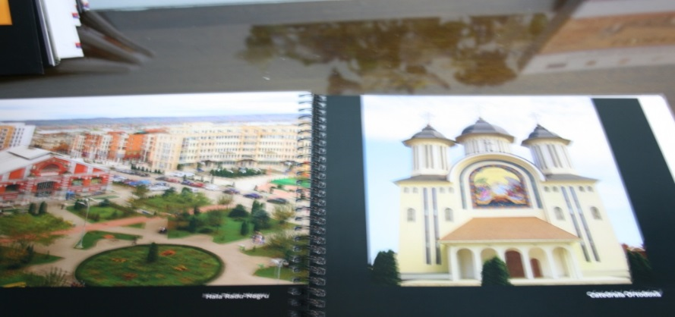
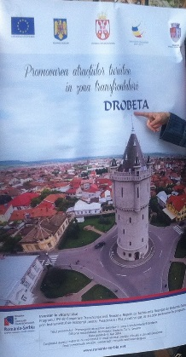
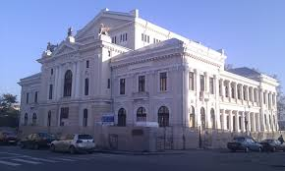
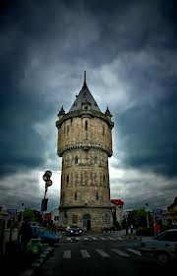

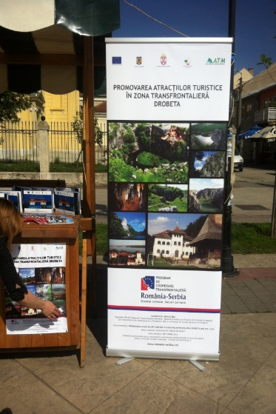
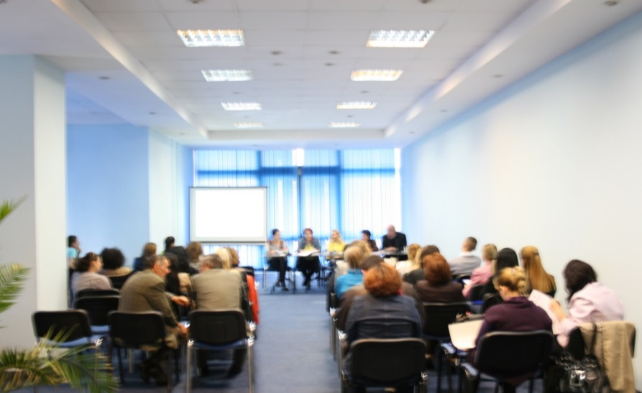
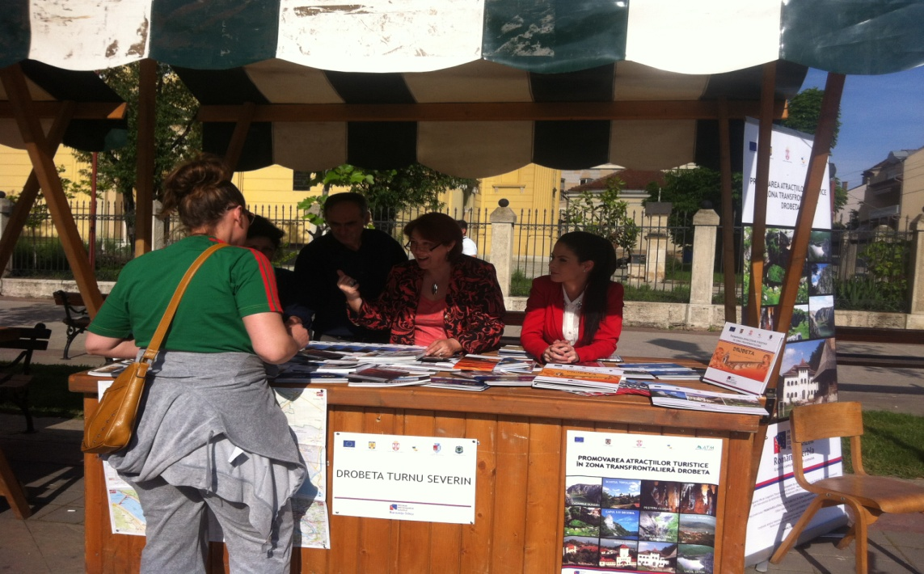

the implementation period (including extensions)
total funds spent/total funds contracted *100
indicators and level of achievement against targets set

