Project information
CALL FOR PROPOSALS | 2
MIS-ETC: | 1328
PRIORITY AXIS: | 1.Economic and Social Development
MEASURE: | 1.4 Support increased levels of R&D and innovation in the border region
PROJECT TITLE: | Pole of Collaboration in New Functional Alloys
ACRONYM: | POCAL
DURATION: | 23.09.2015 – 22.09.2016
IPA FUNDS CONTRACTED: | 822.915,40 €
TOTAL FUNDS CONTRACTED: | 968.135,76 €
ABSORBTION RATE (%): | 94,22%

PROJECT OBJECTIVE(S): | Creation of POCAL Cross-Border Network.  Development of interconnected innovation clusters.  Joint research in Advanced Functional Materials.  Design of the transfer of knowledge mechanisms.  Development and preparation for self-support.
SHORT DESCRIPTION OF THE PROJECT: | The project achieved to create of POCAL Network for researchers, people and companies looking to develop activities related to the field of the project, people in need or looking for a carrier change by training and education.

DEGREE OF ACHIEVEMENT OF INDICATORS: | Indicator Indicator value provisioned in the contract Present indicator value %  Output indicators (1) UM (2) Quantity (3) UM (4) Quantity (5) 6= (5)/(3)*100  Increased importance of R&D/Innovation in the border area Number of activities, actions, initiatives focusing on promoting the importance of or dealing directly with R&D/Innovation 3 Development of research collaborations (Focusing Meeting in Bor, transfer of knowledge and joint research activities) 1 100%  Promotion of the capacity to provide environment for R& D collaborations (Open day in Timisoara Workshop in Bor) 1  Joint research actions 1  Result indicators  Increased competences for the personnel to develop research-related activities Number of researchers involved in the R&D activities 15 Number of researchers involved in the R&D activities 39 260%  Activities strengthening the scientific collaboration Number of joint scientific events 2 Number of joint scientific events 2 100%  Dissemination of the scientific results Number of the scientific papers submitted for publication 6 Number of the scientific papers submitted for publication 14 233.3%  Increased capacity to develop high level research Equipment’s purchased for the laboratories 5 Equipment’s purchased for the laboratories 5 100%  Results of the collaboration protected Number of patent applications 1 Number of patent applications 1 100%  Transfer of knowledge-initiated activities Number of companies informed about the R&D activities 25 No. of companies informed about R&D activities 25 100%

RESULTS ACHIEVED, INCLUDING PHOTOS: | A solid collaboration mechanism was developed for the partnership and improved during the Focus meeting organized in MMJ Bor location.  Updating the fabrication and functional exploration laboratory – the High vacuum microfabrication unit was delivered and is in the process of being installed in a specially prepared room of the LP. The DTA-TGA-DSC devices was delivered and installed at MMI Bor (P2).  Materials development and optimization was performed on copper based shape memory alloys as powder and bulk materials and also on samples processed by severe plastic deformation by accumulative roll bonding and by equal channel angular pressure (on a device especially manufactured.  The Workshop “Innovation in Functional Materials” was organized in the MMI Bor (P2) institution with participation from the UPT (LP) institution and also with the participation of companies potentially interested in the activity of the POCAL partnership.  The Open day event was organized in the Advanced Functional Materials Laboratory of the Polytechnic University Timisoara, with partners from MMI Bor (P2), international guests, researchers and students. During the open day, the research facilities of the partnership were presented and flyers were distributed to the participants.  Two issues of Journal Copper have been published, with papers submitted by both partners. One demonstrator was manufactured and tested. One patent application was submitted.14 papers published.  Transfer of Knowledge Centre was implemented in the partner's location.  Funding applications were submitted for funding based on the joint collaboration. Preparation for self-support was through the preparation of courses contact with companies and promotional materials distributed to companies in the region.

Partnership information
 |  | COUNTRY | COUNTY/DISTRICT | BUDGET(EURO) | CONTACT DETAILS
LEAD PARTNER: | “Polytechnic” University of Timisoara | Romania | Timis | 560.086,00 | Timisoara, P-ta Victoriei nr. 2  Tel. 0040-256-403655
PARTNER 2: | Mining and Metallurgy Institute Bor | Serbia | Borski | 408.049,76 | Bor, Zeleni bulevar 35  Tel. 00381 30 454 108

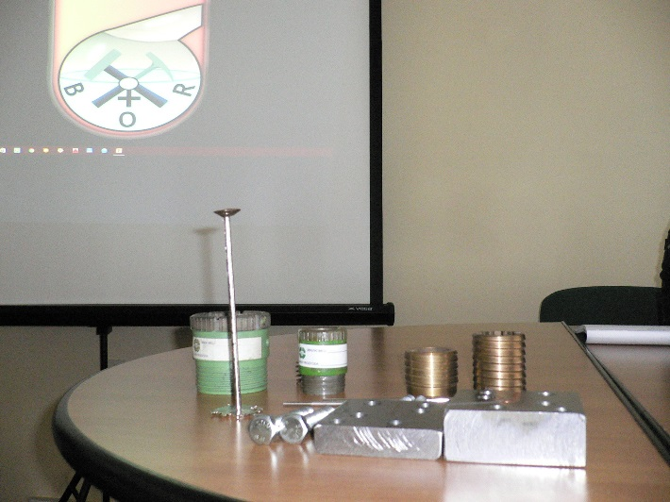
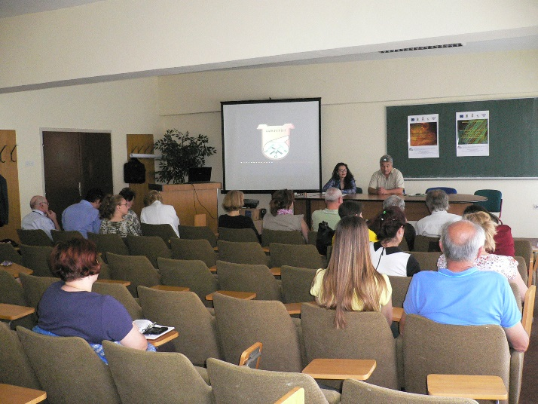
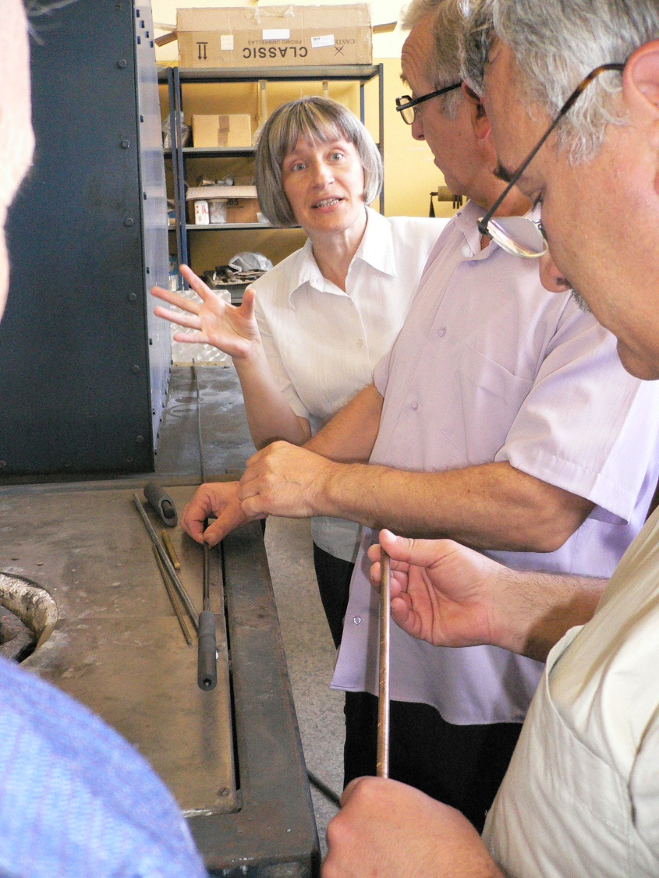
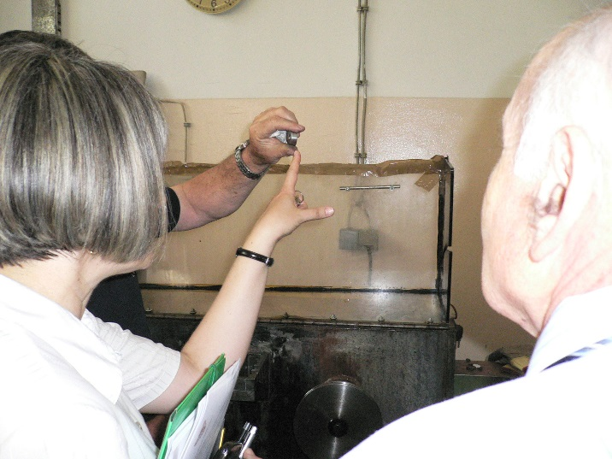
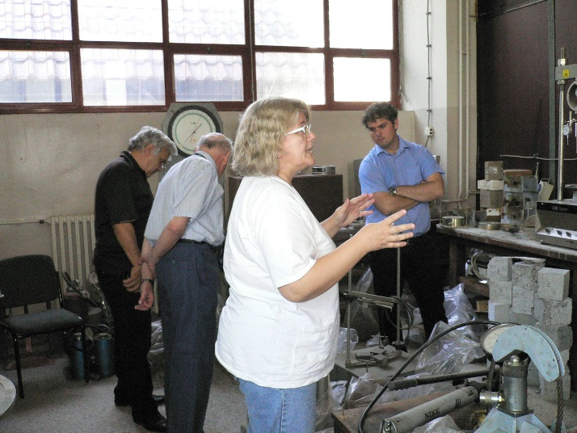

the implementation period (including extensions)
total funds spent/total funds contracted *100
indicators and level of achievement against targets set

