Project information
CALL FOR PROPOSALS | 2
MIS-ETC: | 1327
PRIORITY AXIS: | 3. Promoting “people to people” exchanges
MEASURE: | 3.3 Increase educational, social cultural and sporting exchanges
PROJECT TITLE: | „Rock-n-River“ - Creating a Youth Friendly Ambience Along the Tamis River
ACRONYM: | „Rock-n-River“
DURATION: | 29.12.2012 – 28.06.2014
IPA FUNDS CONTRACTED: | 250.137,15
TOTAL FUNDS CONTRACTED: | 294.279,00
ABSORBTION RATE (%): | 91,73
PROJECT OBJECTIVE(S): | The overall project objective was to build the capacities needed for the realisation of the youth’s needs and the cross-border exchange.  Creating conditions for the cultural, sports and recreational youth activities in Pancevo.  Making the Study of Greenfield Area Feasibility on the Caransebes’s bank of the Tamis River.  Organising workshops for the young in Pancevo (Serbia) and Caransebes (Romania), in order to help knowledge exchange when it comes to strategic, project planning and the values of the EU.  Starting cross-border cooperation between the young, by organising joint concerts in Caransebes and Pancevo.
SHORT DESCRIPTION OF THE PROJECT: | The project enabled the realisation of the cross-border cooperation, in order to encourage learning, experience exchange between the youth of Pancevo and Caransebes by using joint cultural, sports and recreational activities.  In this regard a stationary platform with piers and all the necessary additional equipment for conducting cultural and artistic events on the Tamis banks in Pancevo and in the city centre was procured by City of Pancevo.  A feasibility study for the Greenfield zone which was intended to be used for building a youth centre on the Tamis banks in Caransebes was realized.  Two workshops for young people were held, one in Pancevo entitled “I’ve got a plan!” and one in Caransebes entitled “European Youth in Romania”. The sports clubs: Rowing Club "Tamis", Canoe Kayak Clubs "Pancevo" and "Navigator” from Pancevo participated in the event “Up and Down to the River“.  Music concerts "Rock'n'River" with an accompanying exhibition of photographs entitled "Tamis in shot" was also organized in the Tamis bank in Pancevo and in Caransebes.  https://www.facebook.com/RocknRiver-370339183078246/
DEGREE OF ACHIEVEMENT OF INDICATORS: | Indicator Indicator value provisioned in the contract Present indicator value % 6= (5)/(3)*100  Output indicators (1) UM (2) Quantity (3) UM (4) Quantity (5)  Draft of the strategic plan document of Youth care for the cities of Caransebes and Pancevo Number of the young people who participated (youngsters who participated in the workshops in Caransebes and Pancevo, total 28) 10% of the total number (10% of those youngsters, total 6) Number of the young people who participated 6 100%  The feasibility study on the construction of the Greenfield zone intended for construction of a Youth center on the banks of the Tamis Number of written studies on the Greenfield 1 Number of written studies on the Greenfield 1 100%  Increased awareness of the cultural identity and the historical legacy of cross-border partners on the banks of the Tamis Number of visits 2 Number of visits 2 100%  Improved conditions for cultural events for the young on the banks of the Tamis Number of joint events 2 Number of joint events 2 100%  Result indicators  Increased cross-border cooperation and exchange between the young in the fields of strategic and project planning and European integration Number of meetings with cross-border partner 10 Number of meetings with cross-border partner 11 110%  Number of joint coordinated activities aimed at project and strategic planning and European integration 2 Number of joint coordinated activities aimed at project and strategic planning and European integration 2 100%  Improved cross-border exchange of young people in the field of culture, sport and recreation Number of visits aimed at introducing the partner’s cultural identity 2 Number of visits aimed at introducing the partner’s cultural identity 2 100%  Number of joint cultural events 2 Number of joint cultural events 2 100%  Sport activities presentation 1 Sport activities presentation 1 100%  Improved public awareness on common resources in the region The number of participants in joint activities 1500 The number of participants in joint activities 1500 100%
RESULTS ACHIEVED: | Stationary platform with accessories for the implementation of cultural and artistic events on the Tamis banks in Pancevo was realized.  Feasibility Study for the Greenfield zone-Youth Centre was realised.  2 workshops organized for youth (“Youth in European Romania” in Caransebes, and “I've got a plan!” in Pancevo).  2 music concerts entitled "Rock-n-River" organized, including an exhibition of photographs entitled "Tamis and shot" in Pancevo and in Caransebes in the second half of the project implementation.  Written concepts of the Action Plans for youth care strategy for both cities (Pancevo and Caransebes) were realized.

Partnership information
 |  | COUNTRY | COUNTY/DISTRICT | BUDGET(EURO) | CONTACT DETAILS
LEAD PARTNER: | City of Pancevo | Serbia | Southern Banat | 235.489,00 | Pančevo, Trg Kralja Petra I 2-4  Tel. 013/308-830
PARTNER 2: | Municipality of Caransebeş | Romania | Caras-Severin | 58.790,00 | Caransebeş, Piata Revolutiei, No. 1  Tel. +40255 514 885

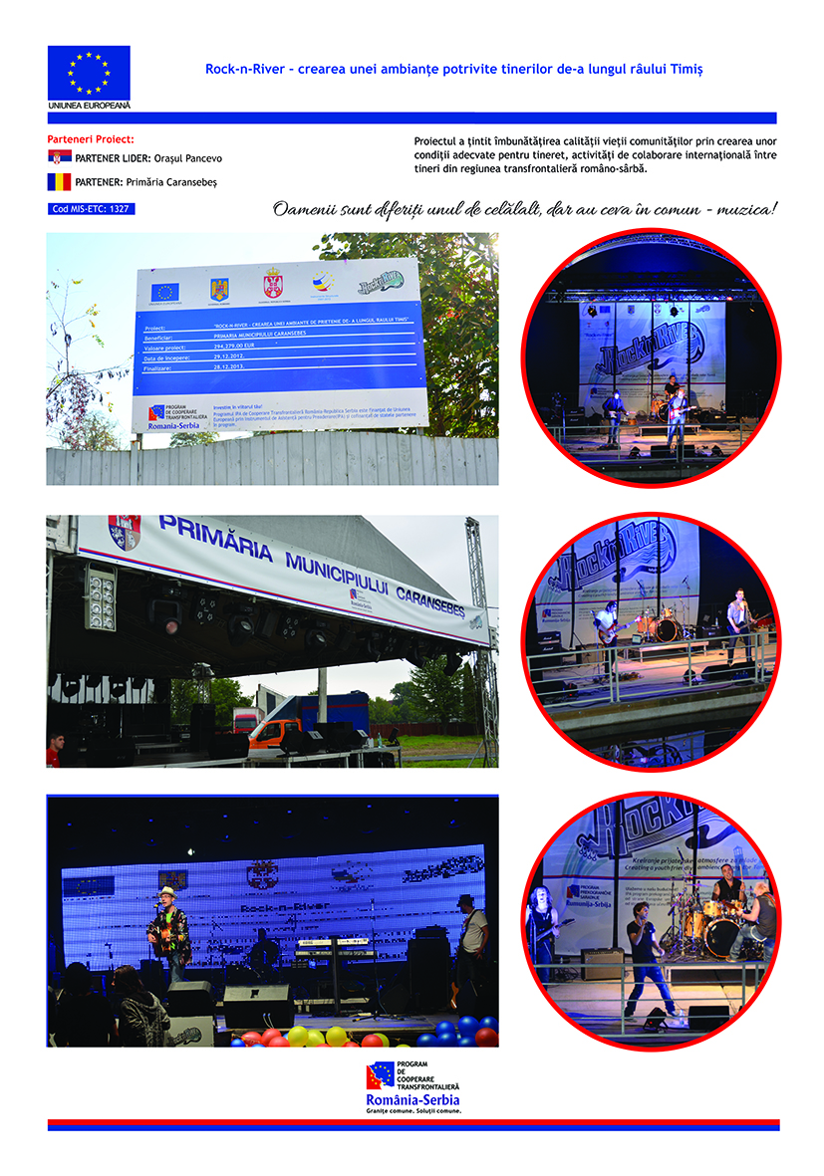

the implementation period (including extensions)
total funds spent/total funds contracted *100
indicators and level of achievement against targets set

