Project information
CALL FOR PROPOSALS | 2
MIS-ETC: | 1324
PRIORITY AXIS: | 1.Economic and Social Development
MEASURE: | 1.2 Develop the tourism sector, including the strengthening of the regional identity of the border region as a tourist destination
PROJECT TITLE: | Living Heritage - an unlimited resource for tourism development
ACRONYM: | Living Heritage
DURATION: | 10.12.2013 – 09.04.2015
IPA FUNDS CONTRACTED: | 263.168,01€
TOTAL FUNDS CONTRACTED: | 309.609,42€
ABSORBTION RATE (%): | 87,68%

PROJECT OBJECTIVE(S): | - To increase the social and economic development of the communities fostering the tourism development through valorizing the local cultural immaterial heritage and the natural as well.  - To increase the degree of knowledge regarding cultural intangible heritage and natural heritage of the cross-border area for 40 students by developing field research in 20 communities from both sides of the border in 10 months period.  - To raise awareness of approx. 28.000 people from 20 investigated communities from the cross-border regarding the opportunities of preserving and smart valorizing of the cultural and natural heritage through tourism.  - To increase the quantity and quality of the touristic attraction of the area in order to create a community development by fostering the business environment during the 15 months.

SHORT DESCRIPTION OF THE PROJECT: | The project aimed to develop the uniqueness of the tourist offer in the cross-border area, created through a win-win relation between the academic environment – the communities - and the business environment by identifying a common cultural intangible heritage and a natural heritage of the communities within the cross-border area as a source for tourism.  The lead partner selected 7 ethno-geographical areas and selected the participants for field research. The research teams included students in Faculty of Letters and Faculty of Geography coordinated by field research coordinators in the project. The research in itself included a fieldtrip in Romania, within 5 ethno-geographical areas, in 12 communities within the counties of Timiş, Caras-Severin and Mehedinți, for 5 days in each area. The Romanian areal are: Timiş County: Timisoara - Herneacova; Caraş-Severin County: Caransebeș and Herculane; Mehedinți County: Dubova and in Serbia: Banatski municipalities of Uzdin, Kikinda and Zrenjanin.  In order to present the results of field research and to bring to the public's attention the traditional products and traditional crafts that were identified by the project's team a indoor fair was organized on 4th-5th-6th of December 2014 in Timisoara at Regional Business Centre  The following books were published:  a.1 one cook book entitled Cookies and Cakes. Sweets from Banat, conceived by Andreea Lisita and Nicoleta Musat, contains a number of receipts for cookies and cakes identified during field research in Banat Area. It is written in 2 languages – Romanian and Serbian and there were published 1000 pieces;  a.2 legend book entitled Walking on the main road: stories and places from Banat, conceived by Eliana Popeti and Miliana Uscatu, contains a number of tales, legends and stories about important places in Banat region, told by people from Banat area and recorded during field research. Moreover, it contains several quotes from famous authors that referred to Banat description. The book is edited in Romanian and Serbian and there were published 1000 pieces;  b.1 narration book + CD – entitled Telling stories ‘bout Uzdin. Memories of a prodigious storyteller is conceived by Otilia Hedesan from interviews carried out with a talented old woman from an investigated village. The book contains also a CD with pictures and interviews, is published in Romanian in 1000 pieces;  b.2 audio DVD with music entitled Broad are the plains of Banat. Songs and singers from Banat; was set up by Diana Mihut and contains songs singed by people in investigated areas and recorded by students that were doing the field research;  b.2 video DVD with dances and painters entitled Once upon a time. Dances from Banat. Naïve painting from Uzdin; set up by Diana Mihut, contains interviews with famous naive painters in Uzdin and dances performed by professional or amateurs’ folkloric ensembles.

 | DEGREE OF ACHIEVEMENT OF INDICATORS: |  | Indicator Indicator value provisioned in the contract Present indicator value % 6= (5)/(3)*100  Output indicators (1) UM (2) Quantity (3) UM (4) Quantity (5)  New or improved cross-border tourism products, joint marketing approaches/ activities or joint tourism information services developed Number of activities, actions, initiatives focusing on promoting tourism in the border area 12 Number of activities, actions, Initiatives focusing on promoting tourism in the border area 12 100%  Result indicators  Increased importance of R&D/Innovation in the border area by students’ exposure to research field Number of activities, actions, initiatives focusing on promoting the importance of or dealing directly with R&D/Innovation 4 Number of activities, actions, initiatives focusing on promoting the importance of or dealing directly with R&D/Innovation 4 100%  other specific indicators  Improved knowledge of the cross border Banat common identity, cultural, natural, linguistic background and quantitative results as resource for tourism 1. Number of Direct participants to the research, 2. number of participants to summer school 3. Number of direct participants to focus group with tourist operators 4. Number of participants to focus group in communities 5. Number and indirect participants to awareness campaign, media promotion and visitors of website 1. 28 2. 25 3. 20 4. 20 5. approx. 28.000 1. Number of Direct participants to the research, 2. number of participants to summer school 3. Number of direct participants to focus group with tourist operators 4. Number of participants to focus group in communities 5. Number and indirect participants to awareness campaign, media promotion and visitors of website 1. 28 2. 35 3. 20 4. 20 5.approx. 28.000 1. 100% 2. 140% 3. 100% 4. 100% 5. 100%  Create the bases for community development founded on touristic products of the cross-border area 1. Number of people who reach touristic products; 2. Number of participants to the fair; 3. Number of visitors to the museums; 4. Number of internet visitors; 5. Number of participants to training courses, to courses for heritage 1.approx. 28.000 2. 500 3. 200 4. 2000 1. Number of people who reach touristic products; 2. Number of participants to the fair; 3. Number of visitors to the museums; 4. Number of internet visitors; 5. Number of participants to training courses, to courses for heritage 1. approx. 28.000 2. 600 3. 200 4. 2000 5. 44 1. 100% 2. 120% 3. 100% 4. 100%  Improved scientific quality of the research quantitative and qualitative data regarding cultural and natural heritage 1. Number of Number of cook-books, Legend and fairy-tale, Books + CD on traditional narrations Number of DVD with traditional music, paintings, Dances 2.conferences Public lectures regarding cultural and natural heritage 3. Number of interviews on Ethnographical and geographical topics. 1. 3 titles books /3000 items 2. and 3 DVDs / 3000 items, 7 3. 200 1. Number of Number of cook-books, Legend and fairy-tale, Books + Cd on traditional narrations, Number of DVD with traditional music, paintings, dances 2.conferences Public lectures regarding cultural and natural heritage 3. Number of interviews on Ethnographical and geographical topics. 1. 3 titles books /3000 items 2. and 3 DVDs / 3000 items, 7 3. 200 100%  Increased flux of information through promotion activities 1.Number of categories of promotional materials elaborated 2.Number of items used for promotion activities 3. Number of press conferences 1.6 2.400 3.7 1. Number of categories of Promotional materials elaborated 2. Number of items used for Promotion activities 3. Number of press-conferences 1. 6 2. 400 3. 7 1. 100% 2. 100% 3. 100%
 | RESULTS ACHIEVED, INCLUDING PHOTOS: |  | - 500 regional maps with 4 thematic routes: ecumenical circuit, wine and spirits route, natural heritage route, the rural ethnographic heritage route  - 2 scientific conferences: one scientific conference held in Timisoara in 14-15 October 2014 in order to present the field research results and one conference held during the final conference in Timisoara, 8th of April 2015 in order to present all the results of the project from a scientific point of view.  - 500 events and holidays calendars, in Serbian and Romanian and English  - Legend and fairy tale books in Serbian and Romanian – 1000 pieces  - Cooking-books in Serbian and Romanian – 1000 pieces  - Audio-books with traditional narrators – 1000 pieces  - Audio CDs with musici from Banat (RS) and Banat (RO) – 1000 pieces  - DVD painters from Uzdin – 1000 pieces  - DVD with traditional dances from Banat – 1000 pieces  - 1 trilingual website designed and on line - https://livingheritage.uvt.ro/  - One winter school at the West University of Timisoara, (26th of February – 2nd of March 2015, more than 50 participants)  - 1 training course in heritage, held in Herculane, 9-13 March, 24 participants  - One training course in tourist guides, held in Buziaș (from 2nd to 6th of March 2015) that had two types of courses, held in parallel sessions: one training course for tourist guides in communities and one training course for tourist guides in the city;  - 1 fair in Timişoara, 80 exhibitors from communities and more than 600 participants (412 visitors, 189 teachers and pupils at workshops, 80 persons in the folkloric assembly, etc.)
Partnership information
 |  |  |  | COUNTRY | COUNTY/DISTRICT | BUDGET(EURO) | CONTACT DETAILS
LEAD PARTNER: |  | West University from Timisoara |  | Romania | Timiş | 111.666,03 | Timişoara, 4, Pârvan Av.  Tel. 0256590009
PARTNER 2: |  | Timis Chamber of Commerce, Industry and Agriculture |  | Romania | Timiş | 106.923,99 | Timişoara, Piata Victoriei 3  Tel. 0374160942
PARTNER 3: |  | Intercultural Institute Timisoara (IIT) |  | Romania | Timiş | 63.320,00 | Timişoara, Bul. 16 Decembrie 1989,Nr. 8  Tel. 0256 498457
PARTNER 4: |  | Regional Chamber of Commerce and Industry Kikinda (CCIK) |  | Serbia | North Banat | 27.699,40 | Kikinda, Trg srpskih dobrovoljaca 48  Tel. +381 (0)230 21-080

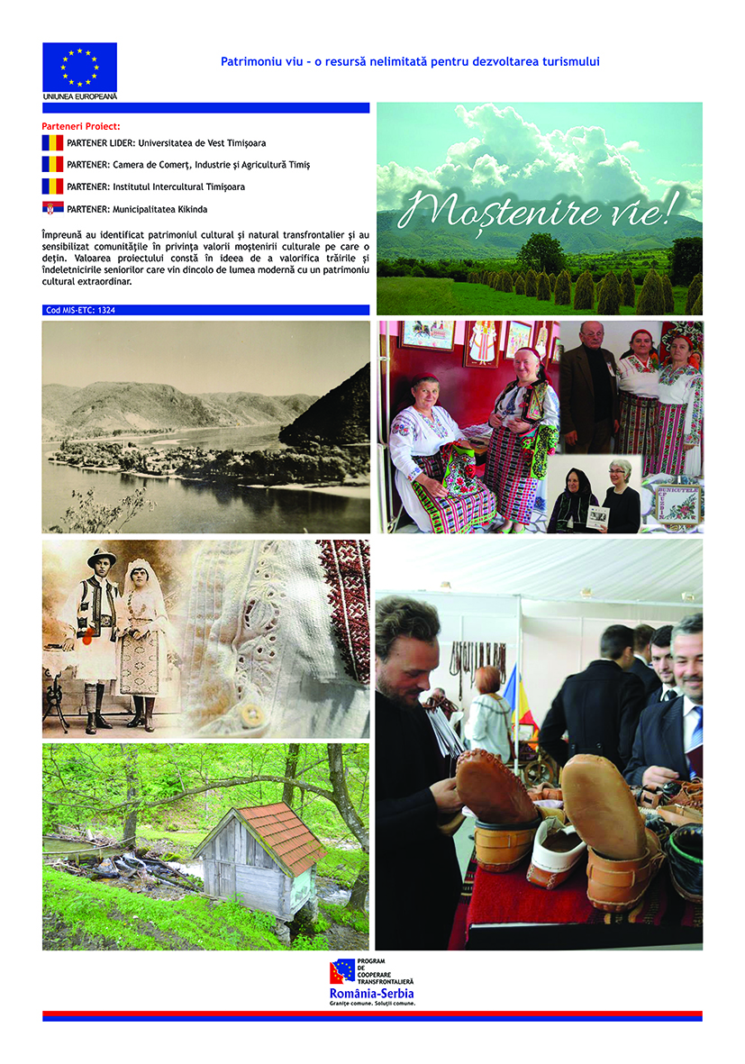

the implementation period (including extensions)
total funds spent/total funds contracted *100
indicators and level of achievement against targets set

