 | Project information
 | CALL FOR PROPOSALS |  | 2
 | MIS-ETC: |  | 1318
 | PRIORITY AXIS: |  | 1.Economic and Social Development
 | MEASURE: |  | 1.3 Promote SME development
 | PROJECT TITLE: |  | Improvement of economic cooperation from the cross-border region Gradinari (RO) - Vrsac (SE) through stimulating the activity of small agriculture producers
 | ACRONYM: |  | AgriCO
 | DURATION: |  | 13.04.2013 – 12.04.2015
 | IPA FUNDS CONTRACTED: |  | 1.692.897,49
 | TOTAL FUNDS CONTRACTED: |  | 1.991.644,10
 | ABSORBTION RATE (%): |  | 75,50
 | PROJECT OBJECTIVE(S): |  | Development of the SME sector and small agriculture producers for a more competitive economy in the cross-border area Romania-Serbia.  Supporting and promotion of minimum 200 SMEs and small agriculture producers by creating a cross-border network for a better trade and economic cooperation exchange - Agricultural Cooperation Center Romania-Serbia (AgriCO).  Increasing the competitiveness of the economy of the Municipality of Vrsac (Serbia) – Gradinari (Romania) region due to the creation of 7 new economic agents within 18 months.  Promoting and supporting the cross-border cooperation in the agricultural sector by organizing at least 3 initiatives/activities focusing on SMEs, small agriculture producers, farmers and craftsmen during the project implementation.
 | SHORT DESCRIPTION OF THE PROJECT: |  | Two new AgriCO markets were built in Vrsac and Gradinari. The food market Gradinari has 690 m² built area and 50-60 places for cross-border SME sellers and local farmers producers (vegetables/fruits, meat, dairy and flowers). The market from Gradinari also has an animal marketplace (330 m²) for 175 heads.  The food market from Municipality of Vrsac has 2,401 m² built area and 150-160 places for SMEs (vegetables, fruits, meal, fish, broth, dairy, flowers), equipped with laboratory analysis.  The AgriCO network which was created through the project involves not only cross-border cooperation in the agriculture domain, but in industry and services also. Through the 2 food markets, the AgriCO network expanded. The partners organized regular events to promote the products of about 200 SMEs, small agriculture producers, farmers, which sell in the 2 markets and are members of the AgriCO network.
 | DEGREE OF ACHIEVEMENT OF INDICATORS: |  | Indicator (1) Indicator value provisioned in the contract Present indicator value % 6= (5)/(3)*100  UM (2) Quantity (3) UM (4) Quantity (5)  Project indicators  Equipment for the project team IT equipment 8 IT equipment 8 100%  Audit Reports of audit 1 Reports of audit 1 100%  Promotion of the project Conferences 2 Conferences 2 100%  Project dissemination in media Press releases 4 Press releases 4 100%  Ads in media 6 Ads in media 6 100%  Video spot 1 Video spot 1 100%  Promotional materials Role-up banner 2 Role-up banner 2 100%  Bal pens 150 Bal pens 150 100%  Notebooks 150 Notebooks 150 100%  Flyers 8000 Flyers 8000 100%  Commemorative plaques 2 Commemorative plaques 2 100%  T-shirts 150 T-shirts 150 100%  Portfolio 1000 Portfolio 1000 100%  Banners 4 Banners 4 100%  Posters 700 Posters 700 100%  Physical infrastructure construction in Municipality of Vrsac Food-market (2.401 m², 96 parking places, 18 sellers zones, 1 analysis laboratory, 150-160 selling places) 1 Food-market (2.401 m², 96 parking places, 18 sellers zones, 1 analysis laboratory, 150-160 selling places) 1 100%  Physical infrastructure construction in Gradinari Village Food-market (690 m², 12 parking places, 4 seller’s zones, 50-60 selling places) 1 Food-market (690 m², 12 parking places, 4 seller’s zones, 50-60 selling places) 1 100%  Animal Market (330 m² platform area, 175 animal stalls) 1 Animal Market (330 m² platform area, 175 animal stalls) 1 100%  Cross-border cooperation network Networks 1 Networks 1 100%  Events for supporting and promoting the SMEs sector Events 3 Events 3 100%  Seminars for SMEs producers Seminars 3 Seminars 3 100%  Cooperation agreements Contracts 6 Contracts 6 100%  Creation of new jobs Employees 4 Employees 4 100%  Result indicators  Increased SMEs capacity in the border are Number of activities, actions, initiatives focusing on promoting SMEs activity 4 Number of activities, actions, initiatives focusing on promoting SMEs activity 4 100%
 | RESULTS ACHIEVED: |  | 1. Creation of the food market AgriCO from Municipality of Vrsac.  2. Creation of the food market and the animal market AgriCO from Local Council of Gradinari and of the animal market.  3. Creation of the cooperation network in the Romania-Serbia cross-border region for a better trade and economic cooperation exchange.  - Initiatives for promoting and increasing the SMEs capacity implemented.
Partnership information
 |  |  |  | COUNTRY | COUNTY/DISTRICT | BUDGET(EURO) | CONTACT DETAILS
LEAD PARTNER: |  | Municipality of Vrsac |  | Serbia | South-Banat | 1.271.966,50 | Vrsac, 1, Trg Pobede  Tel. +381 (0) 13 800-501
PARTNER 2: |  | Local Council of Grădinari |  | Romania | Caras-Severin | 719.677,60 | Gradinari, no.190  Tel. +40 255 575 722

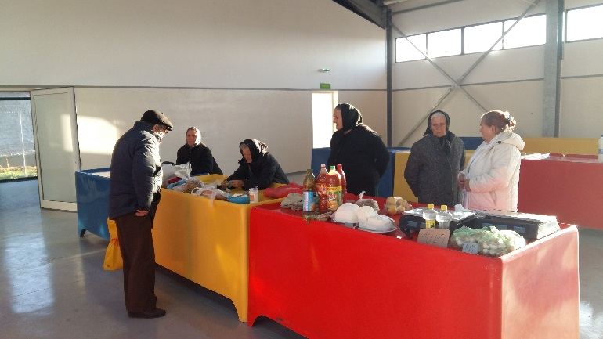
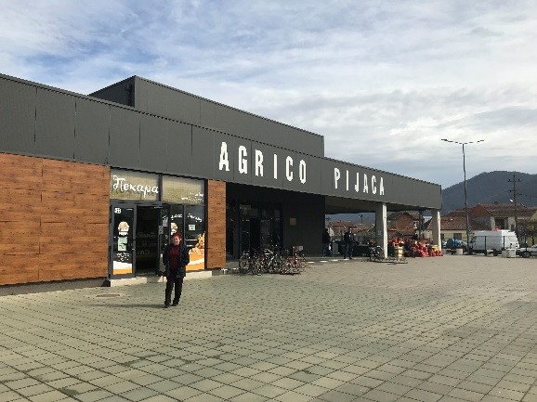
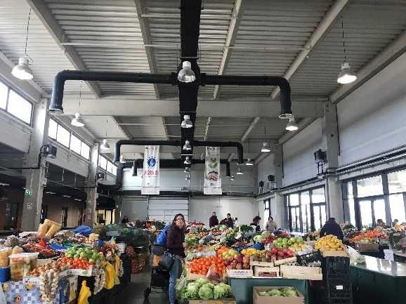
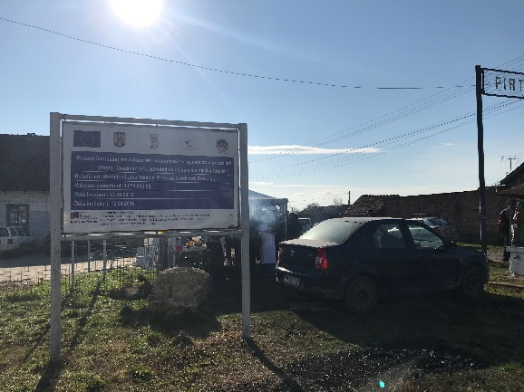

the implementation period (including extensions)
total funds spent/total funds contracted *100
indicators and level of achievement against targets set

