Project information
CALL FOR PROPOSALS |  | 2
MIS-ETC: |  | 1306
PRIORITY AXIS: |  | 1.Economic and Social Development
MEASURE: |  | 1.3 Promote SME development
PROJECT TITLE: |  | Support to SME – the wheel of development in the region
ACRONYM:
DURATION: |  | 29.12.2012 – 28.12.2013
IPA FUNDS CONTRACTED: |  | 292.808,00
TOTAL FUNDS CONTRACTED: |  | 344.480,00
ABSORBTION RATE (%): |  | 93,22
PROJECT OBJECTIVE(S): | To increase the competitiveness level of SMEs in the cross-border border region between Romania and Serbia.  To create the conditions for development of SMEs through a process of mentoring.  Contribution to a process of decreasing of unemployment level of highly educated people in the border region.
SHORT DESCRIPTION OF THE PROJECT: | In all former socialist countries, the last decade of the 20th century was marked by reforms and transition to a market economy. In all countries in transition, the process of political and economic transformation is based on the development of the private sector and entrepreneurship, as well as on the creation of conditions for the establishment and development of small and medium sized enterprises. Lack of access to business advisory services has hindered SME growth. The project strengthened not just SMEs owners, but also business service providers, enabling them to develop institutionally and provide existing and new businesses with competitive skills on an ongoing sustainable basis. Improving SMEs’ access to skills has been facilitated through education and training programs including human resource management, business skills, inventory management, and market and financial access programs.

DEGREE OF ACHIEVEMENT OF INDICATORS: | Indicator Indicator value provisioned in the contract Present indicator value % 6= (5)/(3)*100  Output indicators (1) UM (2) Quantity (3) UM (4) Quantity (5)  Serbian senior experts and Serbian highly educated unemployed experts trained regarding process of mentoring Number of educated experts 25 Number of educated experts -27 junior experts and 10 senior experts from Zrenjanin and Pančevo 37 148%  SMEs from South Banat and SMEs from Middle Banat benefited from consulting services provided by consulting teams Number of consulting services 240 Number of consulting services (30 SMEs from South Banat and 30 SMEs from Middle Banat) 240 100%  B2B meetings implemented Number of participants 60 Number of participants 62 103%  Study tour implemented Number of participants 21 Number of participants 24 114%  Project promoted to a professional and wider public Number of different kinds of promo material (leaflets, brochures, TV, radio, newspaper, billboards, promo movie…) 4000 + 2000 + 1000 + 1000 + 1000 + 3+5+5+1+2 Number of different types of promo material (leaflets, brochures, TV, radio, newspaper, billboards, promo movie…) 9016 (4000+2000 brochures, 1000+1000+1000 leaflets, 3=2 billboards and 1 logo, 5 TV promotions, 5 radio promotions, 2 conference, 1 movie) 100%  Result indicators  Increased SME’s capacity in the border area - 5 Serbian senior experts educated -10 South Banat and 10 Middle Banat junior experts trained - 30 South Banat and 30 Middle Banat SMEs received consulting - 1 B2B meeting organized - 1 Study tour implemented - 1 project promotion implemented 5 10+10 30+30 1 1 1 5 Serbian senior experts educated 10 South Banat and 10 Middle Banat junior experts trained 30 South Banat and 30 Middle Banat SMEs received consulting - 1 B2B meeting organized - 1 Study tour implemented - 1 project promotion implemented 10 16+11 60 1 1 1 200% 135% 100% 100% 100% 100%

RESULTS ACHIEVED: | 20 Serbian highly educated unemployed experts trained regarding process of mentoring  Young educated experts were given the opportunity on one hand to upgrade their theoretical knowledge during the training. On the other hand, they developed practical experience while working with senior experts through process of mentoring. In this way they improved their skills and supplement their theoretical knowledge with the practical experiences.  30 SMEs from South Banat and 30 SMEs from Middle Banat benefited from consulting services provided by consulting teams. During the process of mentoring, SME owners met young professionals who had the opportunity to present their professional qualifications. After first visits, junior experts provided an analysis for each SME they visited. On the basis of information collected during the visits, the expert teams finished analyses for 60 SMEs selected to be beneficiaries of mentoring and consulting services. After the analyses were finally approved by senior experts, during the second visits, Serbian junior experts presented to the SMEs their analysis and proposals of actions for facing the challenges which are identified in order to overcome it. During the last visits the expert teams monitored whether the proposed measures are implemented and what are their effects.  B2B meetings implemented and Study tour implemented  The business 2 business meetings provided to the Serbian experts the opportunity to improve their own knowledge based on experiences that are presented by Romanian consultants. The meetings was also an opportunity for establishing new contacts between experts from both side of border with the aim of beginning future cooperation that might lead to improvement of economic development of border region.  Project activities and project results presented to the professional public, but also promoted to a wider public  Leaflets were printed and distributed to partners and the wider public: Leaflets are three-lingual (Serbian, Romanian, and English). Three thematic brochures were printed and distributed (in Serbian, Romanian and English). 2 billboards were set up. In accordance with Visibility plan wide means of communication were used to spread information about project. There were prepared press releases regarding the implemented of the project activities and results achieved. A mass media promotion plan has been developed and implemented in order to diseminate the project results.  Created conditions for making of new working places for unemployed experts  Unemployed experts participated in trainings regarding consulting services and mentoring. After the trainings, during the visits performed, interwies with SMEs owners and managers were conducted and Serbian junior experts had the opportunity to prove them their skills and knowledge that potential employers might need, thus giving them the possibility to consider starting up their own business and to offer consulting services to companies on the market or to become employees of the SME’s.

Partnership information
 |  | COUNTRY | COUNTY/DISTRICT | BUDGET(EURO) | CONTACT DETAILS
LEAD PARTNER: | Regional Chamber of Commerce and Industry Pancevo | Serbia | South Banat | 195.600,00 | Pancevo, Zmaj Jovina 1a  Tel. +381 13 343 255
PARTNER 2: | Caraş-Severin Chamber of Commerce, Industry and Agriculture | Romania | Caraş-Severin | 55.680,00 | Reşiţa, str. Petru Maior nr. 71  Tel. 0255 215 829
PARTNER 3: | Regional Agency for Socio Economic Development – Banat Ltd. | Serbia | Middle Banat | 93.200,00 | Zrenjanin, Čarnojevićeva 1  Tel. +381(0)23 510 567

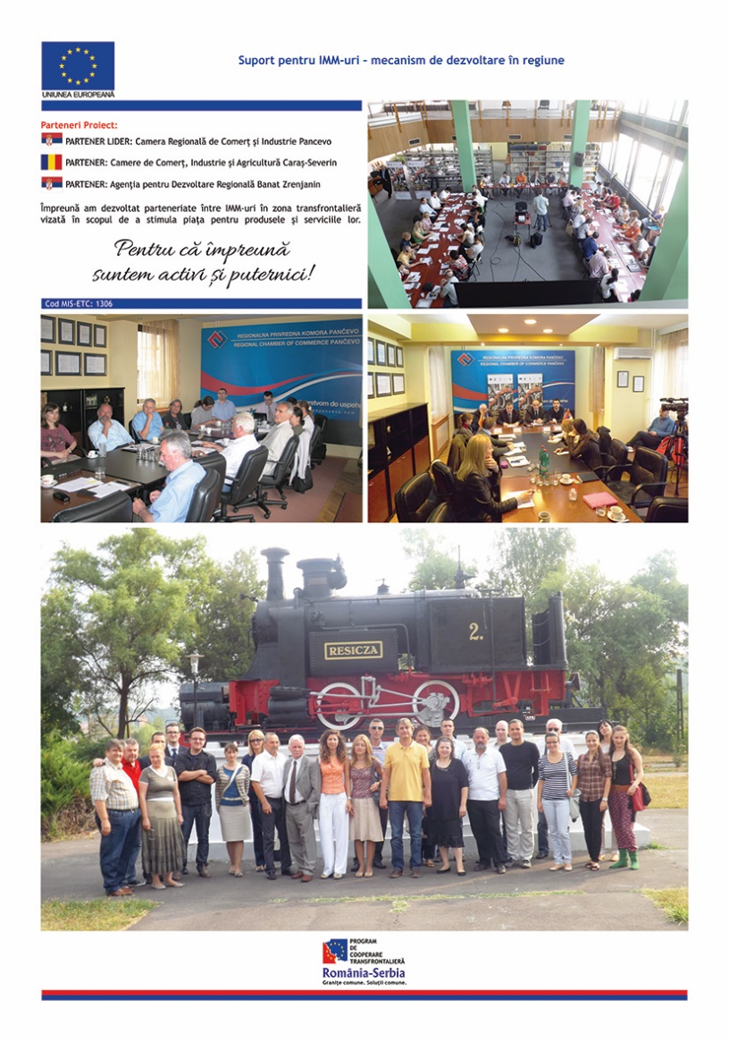

the implementation period (including extensions)
total funds spent/total funds contracted *100
indicators and level of achievement against targets set

