Project information
CALL FOR PROPOSALS | 2
MIS-ETC: | 1298
PRIORITY AXIS: | 1.Economic and Social Development
MEASURE: | 1.4 Support increased levels of R&D and innovation in the border region
PROJECT TITLE: | BANAT SUN 4 ALL - Pilot project for promotion and implementation of solar energy for water heating
ACRONYM: | “Banat Sun 4 ALL”
DURATION: | 01.01.2016 -31.12.2016
IPA FUNDS CONTRACTED: | 646.171,07
TOTAL FUNDS CONTRACTED: | 854.941,60
ABSORBTION RATE (%): | 84,26
PROJECT OBJECTIVE(S): | Improvement and modernization of the heating system, through research of possibilities for transfer to renewable energy resources in Pancevo (Serbia) and Lugoj (Romania).  Creation of preconditions for improvement and modernization of heating system in Lugoj through the design of the Feasibility study and Technical Project documentation.  Creation of preconditions for improvement and modernization of heating system in Pancevo through construction of solar collector system.  Ensuring continuous monitoring of practical application of the pilot system through implementation of the first R&D unit of its kind in Pancevo for cross-border activities with Romania.  Raising the awareness of citizens about energy efficiency, rational production and consumption, environment protection and renewable resources through the promotion of the project in the cross-border region.
SHORT DESCRIPTION OF THE PROJECT: | The City of Pancevo as an administrative economic centre of South Banat in Serbia with a highly developed chemical industry is marked as a black spot on the ecologic map of Europe. The content of this pilot project was to determine the justifiability of applying solar energy, mainly for the purpose of water heating consumed within the system of public central heating in Pancevo and public buildings in Lugoj. Construction of the system of solar collectors decreased the consumption of fossil energy resources by a minimum of 8 %. The construction of solar panels for water heating created preconditions for ensuring continuous monitoring of practical application of the pilot system. The project has served to significantly raise awareness of citizens of the importance of renewable energy resources from the aspects of more economical production, environment protection, implementation of new technologies, and delivery of higher quality service.
DEGREE OF ACHIEVEMENT OF INDICATORS: | Indicator Indicator value provisioned in the contract Present indicator value % 6= (5)/(3)*100  Output indicators (1) UM (2) Quantity (3) UM (4) Quantity (5)  Increased share of solar energy use in water heating system in Pancevo % 8% % 8% 100%  Decreased CO2 emission in Pancevo t/per year 200 t/per year 202,81 101,41%  Result indicators  Increase importance of R&D/Innovation in the border area No. of units 1 No. of units 1 100%  Feasibility study and project for using solar energy in Romania No. of units 7 No. of units 7 100%  Technical design for solar unit in Pancevo made No. of units 1 No. of units 1 100%  Established R&D unit in Pancevo with solar energy water heating process monitoring system No. of units 1 No. of units 1 100%  Raised awareness of citizens and increased technical exchange of experience No of events 10 No of events 10 100%
RESULTS ACHIEVED: | The Feasibility Study, Technical design and Energy Audit were developed for 7 buildings in Lugoj (one application of solar energy compiled).  System of solar collectors installed in Pancevo.  At the Congress “International Days of energy and investments", Project "Banat Sun 4 All" was showcased as a good example, within the topic panel "Using renewable energy sources in district heating systems".  The Workshop regarding the solar energy and its application was organized in Lugoj.  The City of Pancevo's web site www.pancevo.rs has a banner of the project in both English (http://www.pancevo.rs/en/about-pancevo/banat-sun-for-all/) and Serbian version (www.pancevo.rs/lokalna-samouprava/banatsko-sunce-za-sve/).  120 promo sets were produced and distributed in Pancevo and 3.000 brochures on reducing energy were distributed to the houses in Lugoj.  The mobile solar panel water heater dummy was presented for high-school students and teachers in different municipalities of the region.

Partnership information
 |  | COUNTRY | COUNTY/DISTRICT | BUDGET(EURO) | CONTACT DETAILS
LEAD PARTNER: | City of Pancevo | Serbia | South Banat | 674.760,00 | Pancevo, Trg Kralja Petra I 2-4  Tel. +381 13/308-830
PARTNER 2: | Municipality of Lugoj | Romania | Timis | 180.181,60 | Lugoj, Piata Victoriei nr.4  Tel. 0040-256-352.240
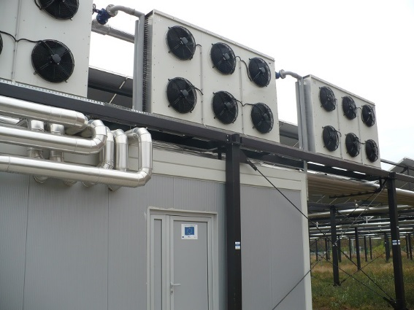
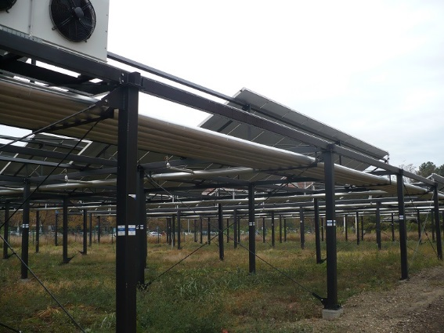
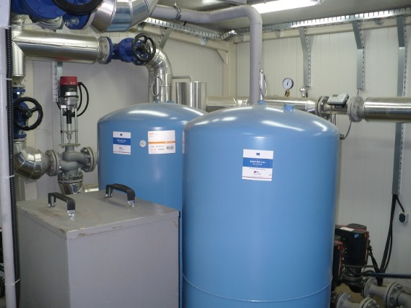
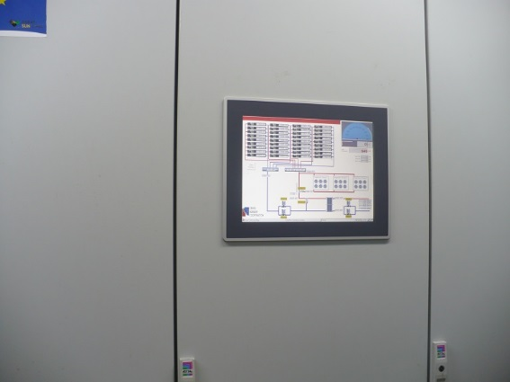

the implementation period (including extensions)
total funds spent/total funds contracted *100
indicators and level of achievement against targets set

