Project information
CALL FOR PROPOSALS | 2
MIS-ETC: | 1294
PRIORITY AXIS: | 1.Economic and Social Development
MEASURE: | 1.3 Promote SME development
PROJECT TITLE: | SMEs support by developing an E-business infrastructure in Timis County and the neighbour Serbian district
ACRONYM:
DURATION: | 27.04.2013 – 26.04.2015
IPA FUNDS CONTRACTED: | 1.408.557,49
TOTAL FUNDS CONTRACTED: | 1.657.126,46
ABSORBTION RATE (%): | 98,28
PROJECT OBJECTIVE(S): | Support to the development of business activities in the border region.  Establishing a suitable model of Business Incubator Centre in Vrsac, Serbia.  Establishing an information system for promoting the business opportunities in the cross-border area.
SHORT DESCRIPTION OF THE PROJECT: | Due to generally poor opportunities for economic development in the past two decades, SMEs from the border region were unable to invest in new knowledge, skills and technologies which resulted in a lower competitiveness level especially in comparison to strong EU Companies.  Problems that were solved through the realization of this project were: lack of knowledge, skills about actual way of SME management and marketing in accordance to EU standards; inability to adopt new technologies in their production processes; lack of initiative of SMEs to present their products and services abroad; no presence of the SMEs on the EU market.  The Project helped potential entrepreneurs start and manage their business and achieve sustainability of their companies. The Serbian part achieved this with reconstruction of 1000 m2 of old storage owned by Vrsac Municipality and creation of 8 production modules (60-150 m2) to support the establishment and development of new companies in Vrsac and thus job generation. BIC staff was trained by experts in order to gain appropriate knowledge regarding the following topics: improving managerial, marketing, financial, innovation skills and skills related to establishing and organization of new companies. The Romanian partner made an IT system which was used to create an interactive platform for promoting business opportunities in the cross-border region.  The platform includes a database with information on population, localities, education facilities, business facilities, economy, GIS information and GIS maps, software for the modelling of data, in order to facilitate to the potential investors to look into various business opportunities scenarios. Data modelling includes software for exploring various business investment projects and their expected results (financial management for projects).  A short video about the project is available at:  https://www.youtube.com/watch?v=tVV1KQJX0l8
DEGREE OF ACHIEVEMENT OF INDICATORS: | Indicator Indicator value provisioned in the contract Present indicator value % 6= (5)/(3)*100  Output indicators (1) UM (2) Quantity (3) UM (4) Quantity (5)  Project indicators  Business Incubator Centre reconstructed and established Number of BIC 1 Number of BIC 1 100  Information system for promoting the business opportunities in the cross-border area Number of systems 1 Number of systems 1 100  All predicted trainings and workshops conducted Number of trainings, 20 Number of trainings, 20 100  Number of participants 200 Number of participants 300 150  Promotion implemented Number of promotional activities 23 Number of promotional activities 23 100  Result indicators  Increased SME’s capacity in the border area Number of activities, actions, initiatives focusing on promoting SME’s activity. 4 Number of activities, actions, initiatives focusing on promoting SME’s activity. 4 100
RESULTS ACHIEVED: | • “Establishment of BIC”  Works on renovation of space for BIC were realized. Business Incubator Centre BIC Vrsac, Serbia is a business support process that accelerated the successful development of start-up and already established companies as future service users by providing entrepreneurs with an array of targeted resources and services. These services are developed by incubator management and offered both in the business incubator and through its network of contacts. A BIC main goal is to produce successful firms that will leave the program financially viable and freestanding but also to be a home for interested tenants with the intention to further develop their business. Training of BIC staff was also realized. Workshops for potential tenants were realized.  • Implemented Information System for promoting the business opportunities in the cross-border area.  The IT system (hardware, licenses and software) fully implemented. The training for the system users was held.  In order to achieve expected results of the project, trainings for 4 BIC staff members were organized, training implemented by Romanian experts. The participants were trained in marketing and SME competitiveness, SME establishment and management, technological and business incubation, innovation business services and training. Also workshops for potential entrepreneurs were organized in order to educate them regarding management, marketing, finance, promotion, distribution, networking etc.  • Preparation, editing and printing of Vrsac Incubator model and service package Guide by the Partners.  This document was an important model for all Serbian Municipalities and development institutions who are working on establishment of business incubators.  • Exchange of experience session in Serbia and Romania  The purpose of this activity was to capitalize the Romanian and Serbian experience in the field of business incubators, industrial parks, network agencies and all kind of business platforms aimed to promote the business opportunities.

Partnership information
 |  | COUNTRY | COUNTY/DISTRICT | BUDGET(EURO) | CONTACT DETAILS
LEAD PARTNER: | Municipality of Vršac | Serbia | South Banat | 682.500,00 | Vrsac, 1, Trg Pobede Street  Tel. +381 (0) 13 800-501
PARTNER 2: | Economic Development Agency of Timis County | Romania | Timis | 974.626,46 | Timisoara, B-dul Revolutiei din 1989, Nr. 17  Tel. 0040256494131
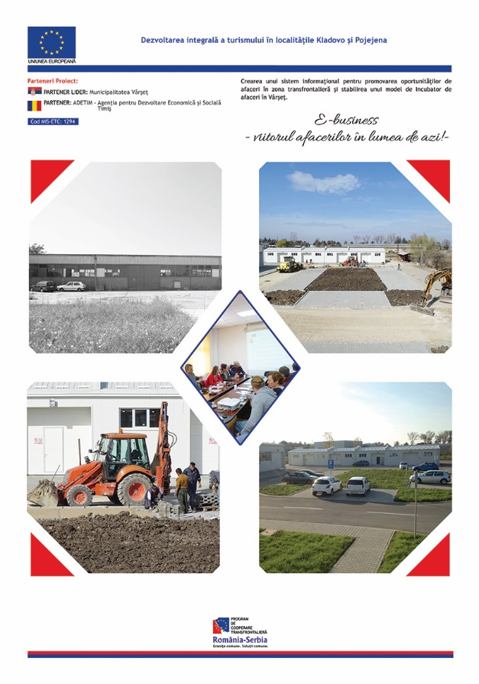

the implementation period (including extensions)
total funds spent/total funds contracted *100
indicators and level of achievement against targets set

