 | Project information
 | CALL FOR PROPOSALS |  | 2
 | MIS-ETC: |  | 1293
 | PRIORITY AXIS: |  | 1.Economic and Social Development
 | MEASURE: |  | 1.2 Develop the tourism sector, including the strengthening of the regional identity of the border region as a tourist destination
 | PROJECT TITLE: |  | Explore Nature Across Borders
 | ACRONYM: |  | ENABO
 | DURATION: |  | 21.05.2013 – 20.11.2014
 | IPA FUNDS CONTRACTED: |  | 534.179,95
 | TOTAL FUNDS CONTRACTED: |  | 628.447,00
 | ABSORBTION RATE (%): |  | 92,92
 | PROJECT OBJECTIVE(S): |  | To develop the tourism economy sector with focus on eco-tourism in the national parks in the Serbian-Romanian border area.
 | SHORT DESCRIPTION OF THE PROJECT: |  | Within the project Feasibility studies have been developed for the rehabilitation of tourist roads (4 km in Romania and 11.5 km in Serbia) and 3 buildings with touristic purpose.  Also, a common tourism plan has been drawn up covering tourist routes, 20 tourist and signage panels were installed along the routes marked on the map, a website that includes all the area-specific destinations has been created http://www.banatsume.rs/eng_indexe.html, touristic and promotional guides, flyers and billboards were developed.  For the sustainability of tourism activities 24 employees were educated in order to improve their knowledge in the field.
 | DEGREE OF ACHIEVEMENT OF INDICATORS: |  | Indicator value provisioned in the contract Present indicator value % 6= (5)/(3)*100  Output indicators (1) UM (2) Quantity (3) UM (4) Quantity (5)  Result indicators:  New or improved cross-border tourism products and services Number of activities, actions, initiatives focusing on promoting tourism in the border area 11 Number of activities, actions, initiatives focusing on promoting tourism in the border area 13 118  Increased SME’s capacity in the border area Number of activities, actions, initiatives focusing on promoting SME’s activity. 5 Number of activities, actions, initiatives focusing on promoting SME’s activity. 5 100  Project indicators  Youth drain has been reduced Average age of inhabitants of the target hamlets - Municipal records SRB 40,9 RO 50,0 Average age of inhabitants of the target hamlets - Municipal records SRB 40,9 RO 50,0 100
 | RESULTS ACHIEVED: |  | 43 families, inhabitants of hamlets in the Cerna-Sat (RO) area have better economic development opportunities.  139 families, inhabitants of Susara (SRB) have better economic development opportunities.  2x12 tourism workers attained trainings on local tourism economy and service mind setting relevant to the sector in order to increase their skills in tourism economy where service orientation is primordial.  In the implementation a 4x4 car for 8 persons, 2 minibuses for 8 persons, and IT equipment were purchased in order to implement the activities. Provision of 7+1 vans increased the mobility in the park for tourists, citizens and tourism workers. Good signalization and public info boards with clear maps increases the exploration opportunities for tourists while being under better control.  In the Pescara 3 original wells and in Romania Domogled Cerna Valley National Park 4 mills were ready to be restored following the development of the feasibility studies achieved at the end of this project.  3 existing buildings were ready to be rehabilitated and assigned to function as eco-training and tourism center following the development of the feasibility studies achieved at the end of this project. Eco education was their primary task. The project has therefore included local school teachers in the target groups.  Each region had a developed tourism plan and relevant action plan in order to support the sustainability of the co-operation under the project. The plans pay special attention to solutions for the increase of garbage entailed by increased tourism.  The project delivered a developed environmental protection plan with focus on waste management.
Partnership information
 |  |  |  | COUNTRY | COUNTY/DISTRICT | BUDGET(EURO) | CONTACT DETAILS
LEAD PARTNER: |  | Forest Estate “BANAT” Pančevo |  | Serbia | South Banat | 217.240,00 | Pančevo, ksima Gorkog 24  Tel. + 381 13 432 899
PARTNER 2: |  | The Administration of Domogled Cerna Valley National Park |  | Romania | Caraş-Severin | 202.083,00 | Băile Herculane, St. Castanilor, no. 21  Tel. 0255.560.582
PARTNER 3: |  | Cornereva Hall |  | Romania | Caraş-Severin | 102.364,00 | Cornereva, no. 1  Tel. 0788.846.375
PARTNER 4: |  | Tourist organization of Pančevo |  | Serbia | South Banat | 106.760,00 | Pančevo, Trg Kralja Petra I 2-4  Tel. +381-(0)13-351-366

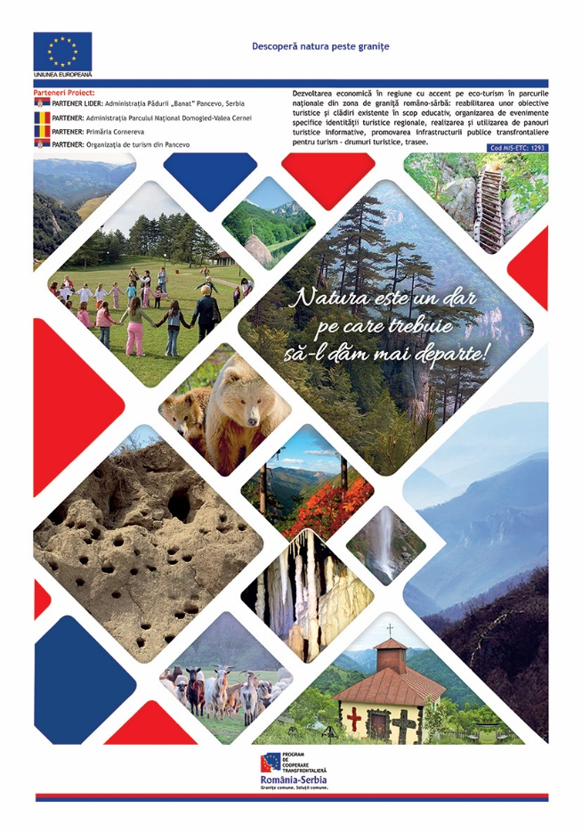

the implementation period (including extensions)
total funds spent/total funds contracted *100
indicators and level of achievement against targets set

