Project information
CALL FOR PROPOSALS | 2
MIS-ETC: | 1286
PRIORITY AXIS: | 3. Promoting “people to people” exchanges
MEASURE: | 3.3 Increase educational, social cultural and sporting exchanges
PROJECT TITLE: | Smart children network
ACRONYM: | SMART
DURATION: | 16.03.2016 -31.12.2016
IPA FUNDS CONTRACTED: | 75.479,15
TOTAL FUNDS CONTRACTED: | 88.799,00
ABSORBTION RATE (%): | 80,58
PROJECT OBJECTIVE(S): | To use multicultural and bilingual settings for functional knowledge stimulation and to increase intellectual capacities and develop talents of pre-school children.  To create preconditions for stimulation of functional knowledge and intellectual capacities in youngest children.  To enlarge the knowledge about neighbours and about EU and prevention of creating biases from an early age.  To increase the efficiency of kindergarten teachers by introducing new teaching methods.
SHORT DESCRIPTION OF THE PROJECT: | The project was based on the fact that multicultural and multilingual settings are extremely stimulating for intellectual capacities development, and that this potential can become a compatible advantage of the region. In order to make this happen, school institutions and parents have to help and to apply exercises for stimulation of learning and to provide additional information on the history and culture of the two nations, as well as stimulate communication and partnership among the youngest children. To create stimulating environment for children development and to make most of the program, it was necessary to completely engage parents. Research has shown a large proportion of parents are relevant in shaping the development of interference, because of making a big mistake in the first five years of children’s life. They are allowing children to use television excessively, to watch video games, and they are not allowing activities such as drill, jumping, crawling...etc. During the training, parents got all the information how to actively participate in the program and how to work with children at home. Also, they have been animated and motivated how to continue working with children after the training was finished.
DEGREE OF ACHIEVEMENT OF INDICATORS: | Indicator Indicator value provisioned in the contract Present indicator value % 6= (5)/(3)*100  Output indicators (1) UM (2) Quantity (3) UM (4) Quantity (5)  Increased social and cultural integration of people in the border areas Number of participants benefiting from cross-border social and cultural events 2240 Number of participants 2240 100%  Improved knowledge of culture, history, society, organizational and institutional structure, and language of the neighbouring country Number of participants gained knew knowledge in events promoting/profiling the neighbouring country 717 Number of participants 717 100%  Improved quality of life and increased attractiveness of the border communities as a living place Number of activities, actions, initiatives developing new or improving existing educational and social services, or improving other local living conditions 30 Number of activities, actions, initiatives 30 100%  Result indicators  The level of consciousness about the significance of creating the stimulating environment for the development of the youngest children is raised. The number of trained parents and kindergarten teachers in Pancevo and Resita Teachers 43 Parents 1430 Students 50 Number of participants Teachers 43 Parents 1430 Students 50 100%  Didactic supplements for the application of program for stimulation of learning are acquired The number of sets which consist of a jigsaw puzzle, a card and a working book 175 The number of sets which consist of a jigsaw puzzle, a card and a working book 175 100%  The communication among the teachers and pre-school children from Serbia and Romania is easier The number of site visits with the option of blog and forum per year 2000 The number of site visits with the option of blog and forum per year 2000 100%  Pre-school children know more about the history and culture of the neighbouring nation and children’s creativity on the theme of differences is developed The number of children included in the program 717 The number of children included in the program 717 100%
RESULTS ACHIEVED: | Creation of the instruments for the initial and final testing within the research on the needs of kindergarten children, parents and teachers regarding innovative teaching methods, i.e. NTC method. Both the initial and final testing were completed, the reports were written and used as starting point for creation of seminars, trainings, publications. 3 instruments for the initial testing were created, i.e. the questionnaires which were distributed on both sides of the border, and the processing of the data was carried out, research findings were used to create seminar contents. Seminars were organized for kindergarten teachers in both sides of the border. The group of students was also formed and participated at the seminar (consisting of workshops and lectures). The results of the activities regarding innovative teaching methods were presented during two events.  Open door day and Smartisimo events were organized in order to aim at the improvement of knowledge of common culture, history and society of the two neighbouring countries.  As a result of the project 43 Kindergarten teachers, 50 students (Pre-school Teacher Training College „Mihailo Pavlov” Vrsac) and over 1430 parents were trained.  The communication among kindergarten teachers, parents and children became easier and children network was created in order to continue and expand this project.
 | Project website: http://smartchildrennetwork.org/ro/titlu/

Partnership information
 |  | COUNTRY | COUNTY/DISTRICT | BUDGET(EURO) | CONTACT DETAILS
LEAD PARTNER: | Preschool Institution “DEČJA RADOST” Pancevo | Serbia | South Banat | 46.895,00 | Pancevo, Zarka Zrenjanina 25  Tel. 013-35-27-18
PARTNER 2: | Kindergarten with Program Extended No.8 Resita | Romania | Caras-Severin | 25.054,00 | Resita, Breazova 5  Tel. 0255251467
PARTNER 3: | Pre-school Teacher Training College “Mihailo Pavlov” Vrsac | Serbia | South Banat | 16.850,00 | Vrsac, Omladinski trg 1  Tel. 013 831 628

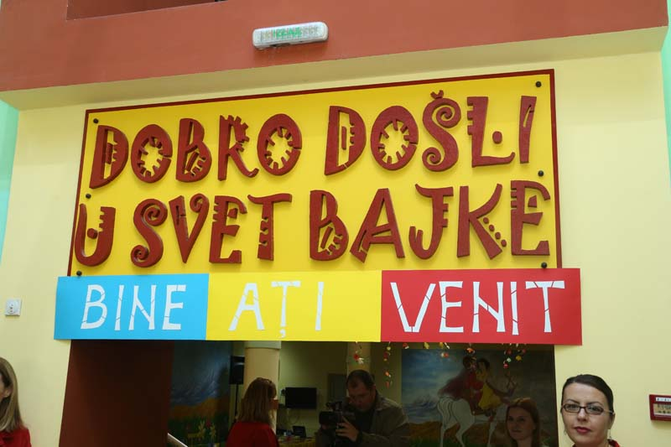
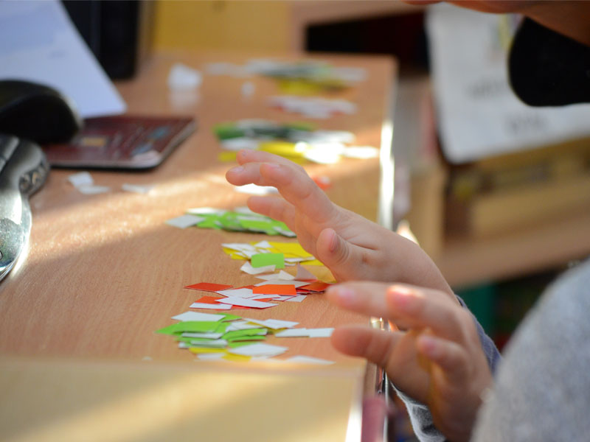
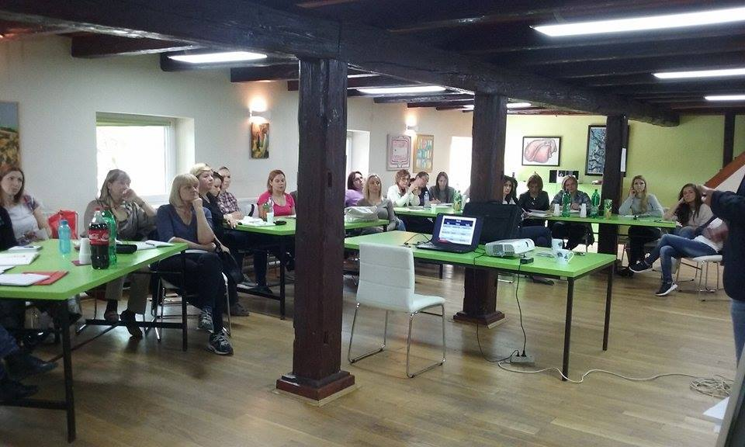

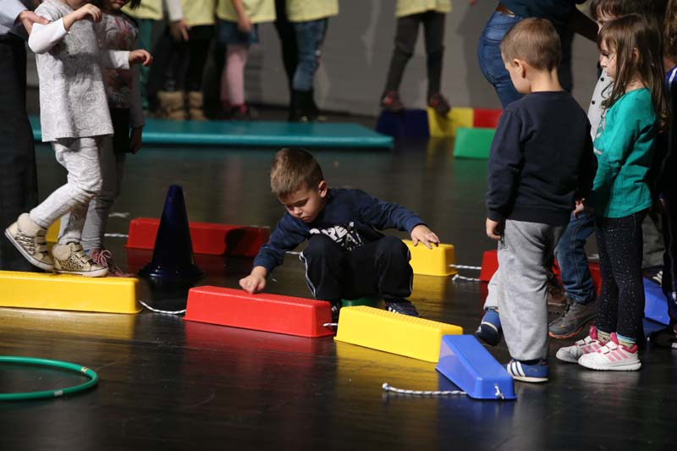
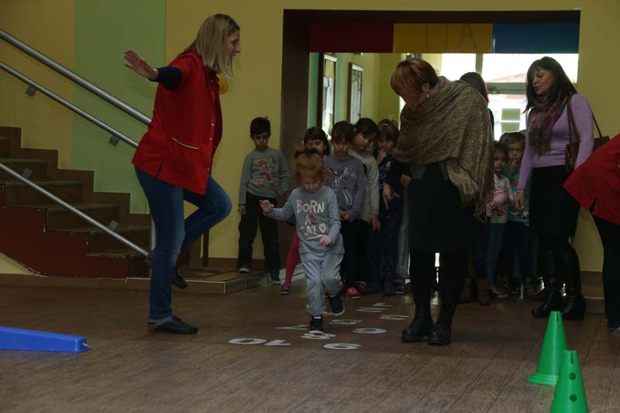
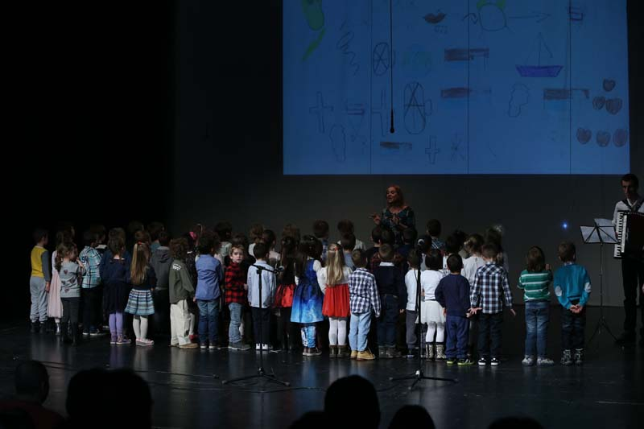
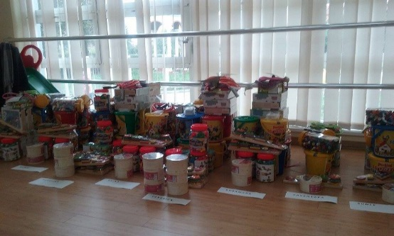

the implementation period (including extensions)
total funds spent/total funds contracted *100
indicators and level of achievement against targets set

