Project information
CALL FOR PROPOSALS | 2
MIS-ETC: | 1283
PRIORITY AXIS: | 2.Environment and Emergency Preparedness
MEASURE: | 2.3 More effective systems and approaches to emergency preparedness
PROJECT TITLE: | Joint management of flood risks
ACRONYM:
DURATION: | 08.04.2016 -31.12.2016
IPA FUNDS CONTRACTED: | 659.243,00
TOTAL FUNDS CONTRACTED: | 828.080,00
ABSORBTION RATE (%): | 82,28
PROJECT OBJECTIVE(S): | Increased security concerning flood risks for Banat inhabitants across the Serbian-Romanian border.  Developing an integrated cross-border flood prevention and management system to improve preparedness by local public authorities in North- Centre- and South Banat districts from Serbia and Timis county from Romania.
SHORT DESCRIPTION OF THE PROJECT: | In order to achieve the project objectives the project partners acquired the specific equipment needed for the local teams to intervene in emergency situations: 3 trenchers, 2 multi-purpose emergency vehicles, 4 SUV, 4 mobile aggregates, 16 mobile pumps, 6 rescue boats, 80 individual equipment sets which are used by the local department of Ministry of Interior from Zrenjanin and 500m inflatable dam, 300m modular dam used by the Inspectorate for Emergency Situations Timis.  Joint management structures were established – Joint Committee JC was composed from representatives of Serbian local authority and project partners` representatives. Joint Technical Committee was composed from flood specialists, professionals and experts in different fields related to flooding, with various professional backgrounds, and they were the technical arm of the decision makers. The JC was developed selection criteria for the members of the JTC and whole process of the selection was transparent, and members are selected according their expertise, experience, and CVs.  Also, trainings for local crisis staff and for community leaders were held - in total 36 days of trainings were held in Serbia with 110 participants were trained.  Another result was drafting of the Joint flood risk management plans.
DEGREE OF ACHIEVEMENT OF INDICATORS: | Indicator Indicator value provisioned in the contract Present indicator value % 6= (5)/(3)*100  Output indicators (1) UM (2) Quantity (3) UM (4) Quantity (5)  Project indicators  Increased number of joint management bodies for flood prevention and protection Joint committee formed 1 Joint committee formed 1 100%  Joint technical committee formed 1 Joint technical committee formed 1 100%  Increased competence of TG s in emergency planning and management techniques Number of participants in training TG3=60 TG4=30 90 Number of participants in training TG3=60 TG4=30 157 174%  Improved technical equipment Number of new equipment purchased 38 Number of new equipment purchased 38 100%  Joint management plan of flood risks Number of developed documents 1 management plan 3 supporting documents 4 Number of developed documents 1 management plan 3 supporting documents 4 100%  Increased public awareness in the field of flood prevention and protection Number of participants on the events 130 Increased public awareness in the field of flood prevention and protection 264 203%  Result indicators  Increased institutional capacity and preparedness in reacting to situations of environmental emergency - flooding Newly elaborated cross-border emergency plans 1 Newly elaborated cross-border emergency plans 1 100%  Training events realized on emergency planning or emergency management techniques 21 Training events realized on emergency planning or emergency management techniques 21 100%
RESULTS ACHIEVED: | Joint management structures were established.  Enhanced competence in risk assessment and preparedness in flood emergency was ensured for 60 practitioners and 30 community leaders.  Improved technical capacity for local teams taking into account resource optimization was ensured.  Joint flood risk management plans were developed.  Awareness of population was raised.
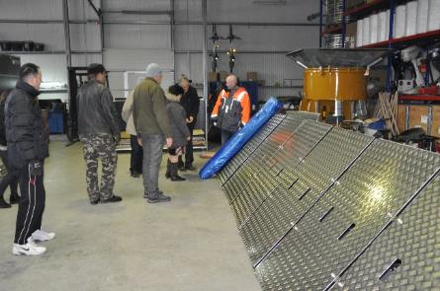
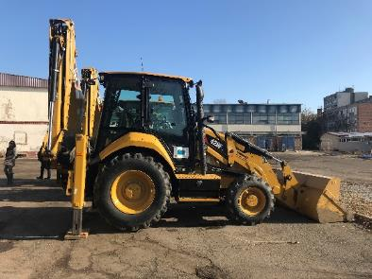
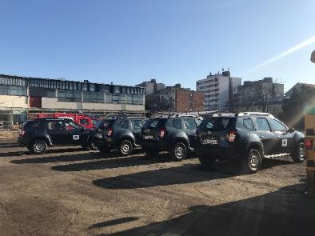
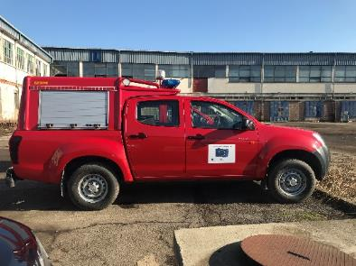
Partnership information
 |  | COUNTRY | COUNTY/DISTRICT | BUDGET(EURO) | CONTACT DETAILS
LEAD PARTNER: | Regional Agency for Socio Economic Development – Banat Ltd. | Serbia | Middle Banat | 523.080,00 | Zrenjanin, Carnojeviceva 1  Tel. +381 23 510 567
PARTNER 2: | Inter Community Development Association for Emergency Situations Management – ADIVEST | Romania | Timis | 305.000,00 | Timisoara, Bvd Revolutiei din 1989, no. 17  Tel. 0040256494131

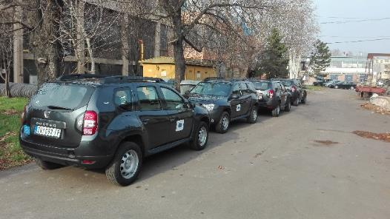
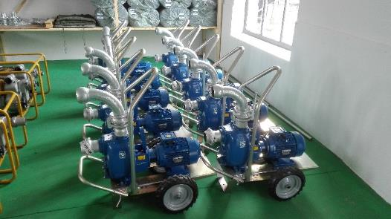
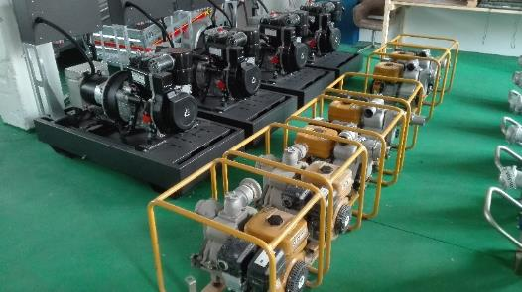

the implementation period (including extensions)
total funds spent/total funds contracted *100
indicators and level of achievement against targets set

