 | Project information
 | CALL FOR PROPOSALS |  | 2
 | MIS-ETC: |  | 1282
 | PRIORITY AXIS: |  | 1.Economic and Social Development
 | MEASURE: |  | 1.2 Develop the tourism sector, including the strengthening of the regional identity of the border region as a tourist destination
 | PROJECT TITLE: |  | Sustainable development of tourism along the Danube
 | ACRONYM: |  | SDTAD
 | DURATION: |  | 14.11.2012 -13.11.2014
 | IPA FUNDS CONTRACTED: |  | 1.734.275,36
 | TOTAL FUNDS CONTRACTED: |  | 2.040.323,95
 | ABSORBTION RATE (%): |  | 87,60
 | PROJECT OBJECTIVE(S): |  | Improving the cross-border public infrastructure for tourism in Mehedinti – Romania and Golubac – Serbia.  Modernization of the access roads to the tourism areas in Mehedinti-Romania and Golubac-Serbia.
 | SHORT DESCRIPTION OF THE PROJECT: |  | Through the implementation of this project the partners have modernized the access roads to the tourism areas: 4,5 km in Mehedinti-Romania and 1,6 km length of new cycle path in Golubac-Serbia.
 | DEGREE OF ACHIEVEMENT OF INDICATORS: |  | Indicator Indicator value provisioned in the contract Present indicator value % 6= (5)/(3)*100  Output indicators (1) UM (2) Quantity (3) UM (4) Quantity (5)  Project indicators  Number of km of modernized access road to/into tourism km 4,5 km km 4,5 km 100  Number of km of cycle paths km 1,6 km km 1,6 km 100  Result indicators  New or improved cross-border tourism products and services Number of activities, actions, initiatives focusing on promoting tourism in the border area 1 Number of activities, actions, initiatives focusing on promoting tourism in the border area 1 100  Improved cross-border transport links and logistic capacity in the cross border area Improved cross-border transport links and logistic capacity in the cross border area Number of activities, actions, initiatives improving existing transport links or tackling logistics capacity 1 Improved cross-border transport links and logistic capacity in the cross border area Number of activities, actions, initiatives improving existing transport links or tackling logistics capacity 1 100
 | RESULTS ACHIEVED: |  | 4,5 km of modernized access road to/into tourism area in Mehedinti County, Romania.  1,6 km length of new cycle path in Golubac, Serbia.  Both modernized segments of roads are located in tourism areas of high interest, namely the Danube Gorge (Clisura Dunarii) and Mehedinti Plateau Geopark, ensuring the tourists` access to touristic attractions and diversifying the tourism products by the new cycle path. Thus, the increased accessibility to/into the tourism areas in Romania and Serbia attracted a larger number of visitors in the region.  Better visibility of the tourism areas on both sides of the Danube.  The visibility/promotion materials achieved within the project framework have helped to strengthen the regional identity of the border area as a tourist destination.
Partnership information
 |  |  |  | COUNTRY | COUNTY/DISTRICT | BUDGET(EURO) | CONTACT DETAILS
LEAD PARTNER: |  | MEHEDINTI COUNTY COUNCIL |  | Romania | Mehedinti | 1.541.698,75 | Drobeta Turnu Severin, 89 Traian street  Tel. +40 372 521113
PARTNER 2: |  | GOLUBAC MUNICIPALITY |  | Serbia | Branicevski | 498.625,20 | Golubac, 15 Cara Lazara Street  Tel. +3981 12 678 128
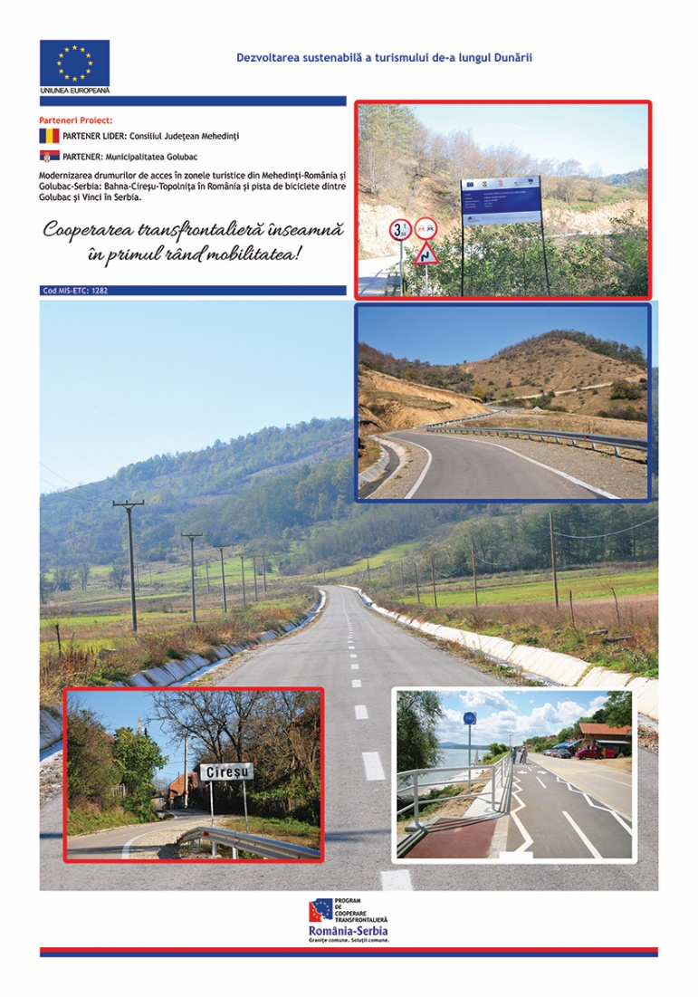

the implementation period (including extensions)
total funds spent/total funds contracted *100
indicators and level of achievement against targets set

