Project information
CALL FOR PROPOSALS | 2
MIS-ETC: | 1280
PRIORITY AXIS: | 3. Promoting “people to people” exchanges
MEASURE: | 3.3 Increase educational, social cultural and sporting exchanges
PROJECT TITLE: | Șișești - Mosna a linkage between communities
DURATION: | 09.11.2012 – 08.11.2013
IPA FUNDS CONTRACTED: | 249.469,90 €
TOTAL FUNDS CONTRACTED: | 293.494,00 €
ABSORBTION RATE (%): | 95,80%

PROJECT OBJECTIVE(S): | It was created a cross-border linkage between local communities from Șișești and Mosna that led to a joint development of an integrated and sustainable socio-economic cross-border area.  Improving the production process and the work conditions in the two handicrafts workshops.  Improving the production process in the two workshops.  Promoting the art and traditions of both Romanian and Serbian peoples.
SHORT DESCRIPTION OF THE PROJECT: | The traditional ceramics and small crafts manufacturers have had a high reputation in the world market for a long time, and are still famous of the high quality and added value of their production. However, their share has shown a decline during the last decades being also a priority area for the European Union. These traditions serve as a major asset in economic terms as well: they generate jobs, household income and stimulate local economic development. The partner regions, endowed with a rich artistic heritage, are nevertheless facing severe problems: globalization exacerbating competition and ageing population of craftsmen, both leading to a continuous decline of the sector. By organizing a folk festival (traditional music and dance) in Șișești Commune (Romania) and in Mosna (Serbia) that was dedicated to the cultural manifestations, folk ensembles from every partner country have been brought together to create a connecting bridge over the Danube bordering countries and promoting the Danube culture. A handicraft and folk-art center have been created through the project, thus developing and promoting the handicrafts products produced in Șișești.

DEGREE OF ACHIEVEMENT OF INDICATORS: | Indicator Indicator value provisioned in the contract Present indicator value % 6= (5)/(3)*100  Output indicators (1) UM (2) Quantity (3) UM (4) Quantity (5)  Promoting arts events folk festival (traditional music and dance) number 2 number 2 100  A development socio-economic cross-border area (Șișești Commune and Mehedinti County). number 2 number 2 100  Promoting production of regional common culture products and exchange of traditional crafts methods number 1 number 1 100  Result indicators  Increased social and cultural integration of people in the border areas number 1 number 1 100

RESULTS ACHIEVED: | - Improved work conditions for the craftsmen that operate in the 2 workshops (ceramic and wool);  - One permanent expositional stand installed in Șișești in the Gh.I. Sisesti Museum;  - 2 electric ceramic furnaces;  - Increased number of tourists in the Cosustea Valley and in the North area of Mehedinți;  - The number of European tourists increased in city Mosna and around it;  - The consolidation of a cross border linkage between the communities on the two banks of the Danube.

Partnership information
 |  | COUNTRY | COUNTY/DISTRICT | BUDGET(EURO) | CONTACT DETAILS
LEAD PARTNER: | Șișești Local Council | Romania | Mehedinți | 171.190,00 | Șișești, 227455  Tel. 0751512633
PARTNER 2: | Mosna Local Council | Serbia | Bor | 122.304,00 | Mosna, 19220  Tel. +38163686900
PARTNER 3: | Mehedinți County Council | Romania | Mehedinți | 0 | Drobeta Turnu Severin, Traian Street, NO 89  Tel. +400372521112

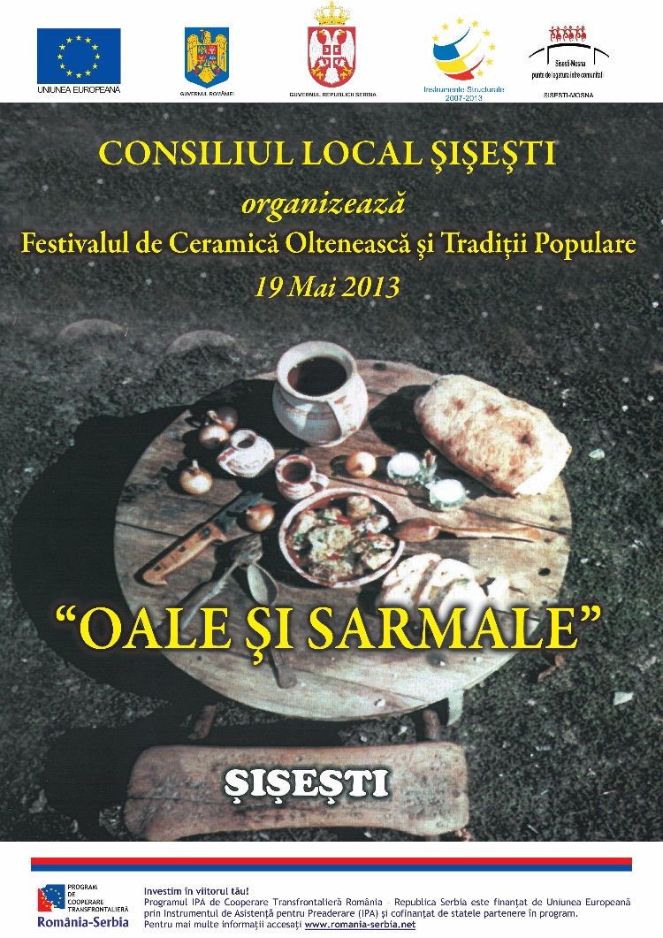
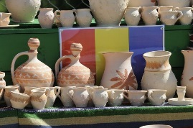
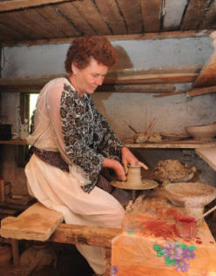
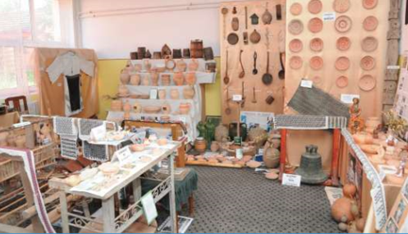
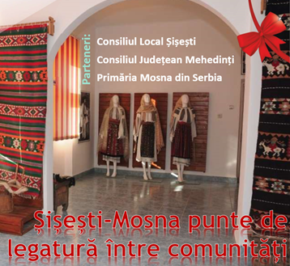
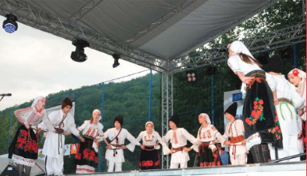
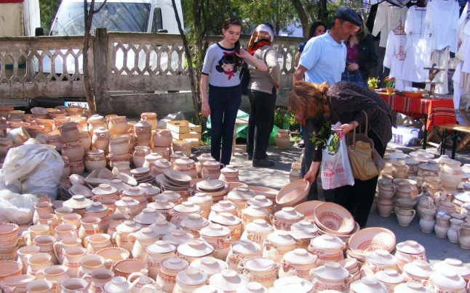

the implementation period (including extensions)
total funds spent/total funds contracted *100
indicators and level of achievement against targets set

