Project information

CALL FOR PROPOSALS | 2
MIS-ETC: | 1278
PRIORITY AXIS: | 3. Promoting “people to people” exchanges
MEASURE: | 3.1 Support the development of civil society and local communities
PROJECT TITLE: | Arrangements of parks as measure for life quality improvement of Banat citizens - Parks for future
ACRONYM: | Parks for future
DURATION: | 05.12.2012 -04.06.2014
IPA FUNDS CONTRACTED: | 190.530,90 €
TOTAL FUNDS CONTRACTED: | 224.154,00 €
ABSORBTION RATE (%): | 75,45 %

PROJECT OBJECTIVE(S): | Improvement of life quality and development of healthy environment in the Serbian and Romanian Banat region.  Protected and preserved cultural heritage.  Educational and cultural cross-border exchange.  Protected and preserved cross-border environment.
SHORT DESCRIPTION OF THE PROJECT: | In the project 2 studies regarding the cultural heritage were realized, there were installed 2 prefabricated-disassembling stages and 2 prefabricated-disassembling amphitheaters.  The park paths were renovated, 400 trees and bushes were planted in parks and the garden furniture was reconstructed in the same parks. In the parks there were posted 2 solar chargers for cell phones and 2 free-internet networks were posted.  Also, 25 expert and stakeholders were educated and 50 volunteers were exchangind knowledge and experience in CBC.

DEGREE OF ACHIEVEMENT OF INDICATORS: | Indicator Indicator value provisioned in the contract Present indicator value % 6= (5)/(3)*100  Output indicators (1) UM (2) Quantity (3) UM (4) Quantity (5)  Rising awareness of joint cultural heritage Number of participants benefiting from cross border social and cultural events 45% Number of participants benefiting from cross border social and cultural events 50% 111  Study of cultural heritage Number of studies 2 Number of studies 2 100  Installation 2 prefabricated-disassembling stages Number of installations 2 Number of installations 2 100  Installation 2 prefabricated-disassembling amphitheaters Number of installations 2 Number of installations 2 100  Planting trees and bushes Number of plants 400 more plants Number of plants 400 100  Reconstructed garden furniture in 2 parks Number of reconstructions works 2 Number of reconstructions works 2 100  Better educated stakeholders Number of stakeholders 125 Number of stakeholders 136 108  Establish material base for sustainability of project results Number of new goods 10 Number of new goods 10 100  2 solar chargers for cell phone posted Number of chargers 2 Number of chargers 2 100  2 Internet networks posted Number of networks 2 Number of networks 2 100  Publication info and promo materials Number of copies 1000 leaflets 400 posters 400 brochures 10 rollups Number of copies 1000 leaflets 400 posters 400 brochures 10 rollups 100  2 web-site established Number of web sites 2 Number of web sites 2 100  Result indicators  Increased social and cultural integration of people in the border area Number of participants benefiting from cross border social and cultural events 125 Number of participants benefiting from cross border social and cultural events 136 108  Improved quality of life and increased attractiveness of the border communities as a living place Number of activities, initiatives for improving local living conditions 12 Number of activities, initiatives for improving local living conditions 12 100  Improved knowledge of culture, history, society, organisational and institutional structure, and language of the neighbouring country Number of participants gained new knowledge in events promoting the neighbouring country 125 Number of participants gained new knowledge in events promoting the neighboring country 136 108
RESULTS ACHIEVED: | In the project 2 studies of cultural heritage were realized, there were installed 2 prefabricated-disassembling stages and 2 prefabricated -disassembling amphitheatres at the headquarters of each partner.  In two of the parks, the paths were renovated, 400 trees and bushes were planted and the garden furniture was reconstructed. In these parks there were posted 2 solar chargers for cell phones and 2 free-internet networks were build.

Partnership information
 |  | COUNTRY | COUNTY/DISTRICT | BUDGET(EURO) | CONTACT DETAILS
LEAD PARTNER: | Centre of volunteers’ and nature conservation movement of Pančevo | Serbia | South Banat | 117.180,00 | Pančevo, Svetog Save 10  Tel. +381 13-334-667
PARTNER 2: | Municipality of Caransebeş | Romania | Caraş-Severin | 106.974,00 | Caransebeş, Piața revoluției Nr. 1  Tel. +402 55 514 885

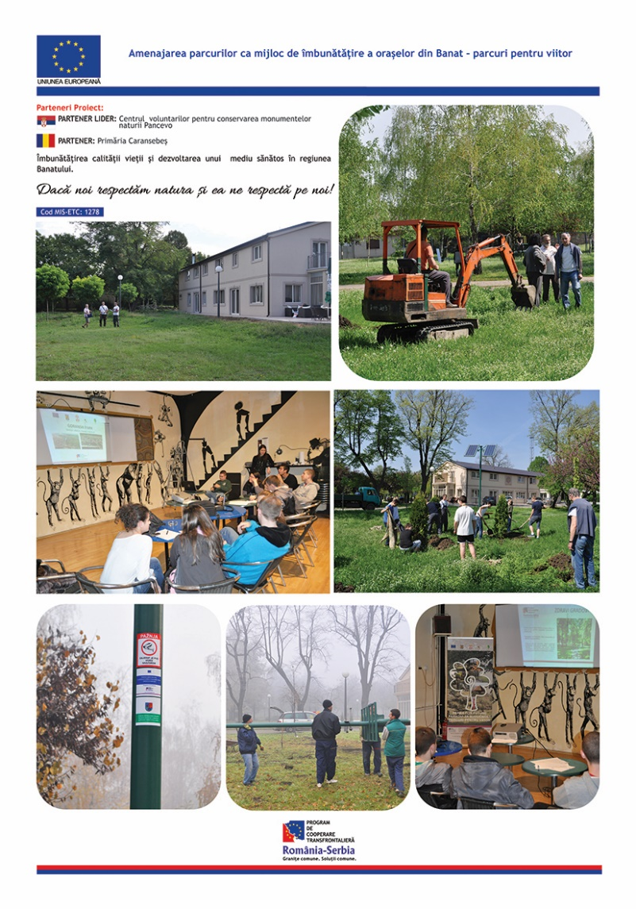

the implementation period (including extensions)
total funds spent/total funds contracted *100
indicators and level of achievement against targets set

