Project information
CALL FOR PROPOSALS | 2
MIS-ETC: | 1276
PRIORITY AXIS: | 1.Economic and Social Development
MEASURE: | 1.2 Develop the tourism sector, including the strengthening of the regional identity of the border region as a tourist destination
PROJECT TITLE: | Sweet weekend at Devojacki Bunar
ACRONYM: | “Sweet weekend”
DURATION: | 18.11.2015 – 17.11.2016
IPA FUNDS CONTRACTED: | 241.803,75 €
TOTAL FUNDS CONTRACTED: | 284.475,00 €
ABSORBTION RATE (%): | 87,88%

PROJECT OBJECTIVE(S): | Achievement of an optimal usage of natural resources and increase of their economic value by improving tourism and promotion of Deliblato Sand and Caras-Severin regions.  Quality and capacity improvement of accommodation in Devojacki Bunar resort.  Support innovative approaches considering manufacturing, marketing and sales of local products and services.  To integrate related economies into one unique rural tourism offer.  To raise awareness and interest of the Banat rural communities towards a sustainable tourism rural development.
SHORT DESCRIPTION OF THE PROJECT: | Within the project natural and cultural resources of rural tourism in the area were promoted. A tourist offer for Devojacki Bunar was made, which is available at http://alibunar.rs/swdb/en , also you can book your accommodation here.  The project consisted also of making and adopted procedures for categorization of the weekend houses in Devojacki Bunar therefore five Weekend houses are marked with visibility tables and furniture are marked with stickers. Weekend Destinations Regional Fair was held on June 11th and June 12th 2016. Tourism Information Cross-Border Centre established and equipped for small meetings and presentations in Municipal facility located on Devojacki Bunar. A new organization was established on November 14th 2016, and registered in Business Registry Agency of Republic of Serbia NGO “Devojacki Bunar” is a new organization for management of weekend houses and their marketing.  Romanian partner organized Study tour and the Serbian delegation visited rural areas/communities from the Romanian cross-border area. They have met successful local actors and saw how the community flourished due to tourism. Participants visited Garana village situated on 30 km from Resita, village Brebu Nou and Danube Canyon and field visits and discovery to famous locations/tourist attractions: Bigar Waterfall, Mraconia Area, Danube Canyon.

 | DEGREE OF ACHIEVEMENT OF INDICATORS: | Indicator Indicator value provisioned in the contract Present indicator value % 6= (5)/(3)*100  Output indicators (1) UM (2) Quantity (3) UM (4) Quantity (5)  New or improved cross-border tourism products, joint marketing approaches/ activities or joint tourism information services developed Weekend house rural accommodation in Devojacki Bunar is new cross-border tourism product During the project, joint Strategic marketing development plan and joint Operational Marketing development plan will be created. Web-site will provide joint tourism information service. 1 1 1 1 Weekend house rural accommodation in Devojacki Bunar is new cross-border tourism product During the project, joint Strategic marketing development plan and joint Operational Marketing development plan will be created. Web-site will provide joint tourism information service. 1 (Weekend house rural accommodation in Devojacki Bunar is new cross-border tourism product) 1 (website) 1 (Strategic marketing development plan) and 1 (Operational Marketing development plan) 100%  Improved capacity and cross-border contacts of SMEs and in the R&D sector Capacity of involved SMEs improved 10 Capacity of involved SMEs improved 10 Capacity of involved SMEs was been significantly improved by this project activities. Cross-border contact with colleagues from the same branches was realized. 100%  Result indicators  New or improved cross-border tourism products and services Number of activities, actions, initiatives focusing on promoting tourism in the border area One new rural tourism offer, Two joint marketing activities One joint promotion tool Number of activities, actions, initiatives focusing on promoting tourism in the border area 4 - Weekend houses rural tourism offer created; - Strategic and Operational Marketing Plan created - Weekend houses regional fair conducted - Web site with on-line booking and joint tourism information 100%  Increased importance of R&D/Innovation in the border area Number of activities focusing on promoting the importance of or dealing directly with R&D/Innovation Five activities on research and development of Codes of Practices, 5 events for support to weekend houses tourism offer development with innovative solutions 5 meetings in Caras-Severin with local stake holders in order to develop innovative solutions Number of activities focusing on promoting the importance of or dealing directly with R&D/Innovation 5 (Code of practice) 5 (Workshops support to categorization) (5 meetings in Caras-Severin) 100%  Increased SME’s capacity in the border area Number of activities, actions, initiatives focusing on promoting SME’s activity. Five Codes of Practices developed Study tour with SMEs as participants Five Local food and beverages offer integrated into weekend house rural accommodation offer Number of activities, actions, initiatives focusing on promoting SME’s activity. 5 (Code of practice) Study tour with SMEs as participants 5 Five Local food and beverages offer integrated into weekend house rural accommodation offer 100%  Project Indicators  Weekend houses officially categorized as accommodation certificate 5 certificate 5 Weekend houses prepared for categorization 100%  Codes of Practices developed and adopted in Municipal Assembly Official Municipal Gazette; Meeting minutes; Documents published 5 Official Municipal Gazette; Meeting minutes; Documents published 5 (Code of practice adopted in Municipal Board, Official Municipal gazette published that, Meeting minutes was prepared and Documents are published) 100%  Established an Organization for managing the whole system of weekend houses rural tourism offer Founding Act; Registration in Serbian Business Registry; Membership cards 1 Founding Act; Registration in Serbian Business Registry; Membership cards 1 New organization “Devojacki Bunar” established, Founding Act prepared, Organization registered in Serbian Business Registry, Membership Cards are prepared. 100%  Established Tourism Information Cross-Border Center Founding Act; Photo and video documentation 1 Founding Act; Photo and video documentation 1 Tourism Information Cross-Border Centre established and equipped for small meetings and presentations in Municipal facility located on Devojacki Bunar. Founding Act prepared. Photo and video documentation prepared. 100%
 | RESULTS ACHIEVED: | • Result 1. Five weekend houses received procedures and adopted Municipal decisions for categorization.  • Result 2: Weekend houses accommodation offer created in Alibunar Municipality.  • Result 3: Devojacki bunar resort and access roads environmentally planned by Plan for controlled waste disposal for both sides of borders  • Result 4. Written and adopted documents of Code of Practice (5 documents)  • Result 5. Created Information and Promotion package (approved by visibility officer and distributed)  • Result 6: Written and adopted documents for Strategic and Operational marketing  • Result 7: Created Extended cross-border Banat strategy  • Result 8: Promoted Devojacki Bunar rural weekend tourism offer  • Result 9. Higher degree of awareness and interest of the Banat rural communities towards a sustainable tourism rural development
Partnership information
 |  |  | COUNTRY | COUNTY/DISTRICT | BUDGET(EURO) | CONTACT DETAILS
LEAD PARTNER: |  | Municipality of Alibunar | Serbia | South Banat | 204.280,00 | Alibunar, Trg Slobode 4  Tel. +381 13 642 105
PARTNER 2: |  | Euroland Banat Association | Romania | Caras-Severin | 80.195,00 | Resita, Al. Galati 4/3/6  Tel. +40 745 126 876

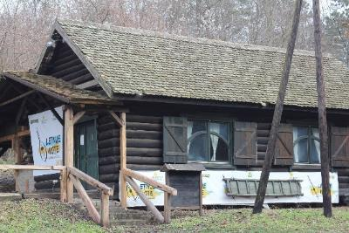
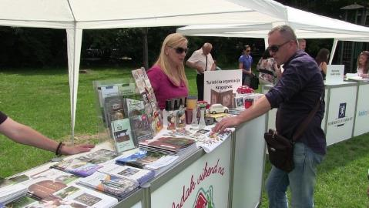
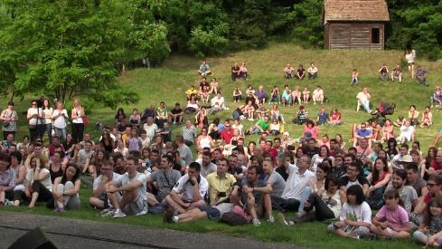
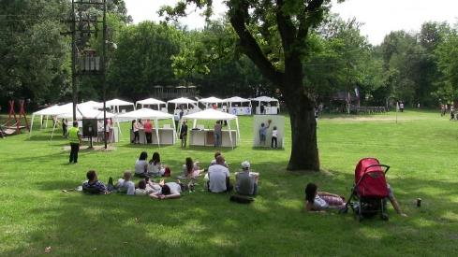
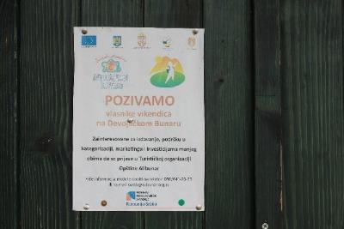
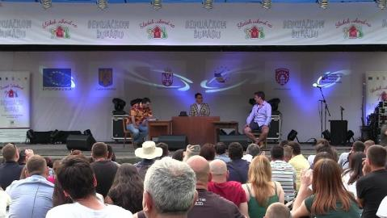
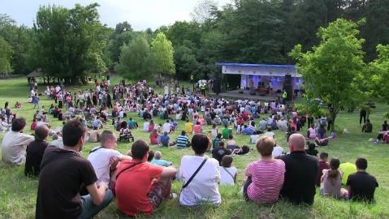
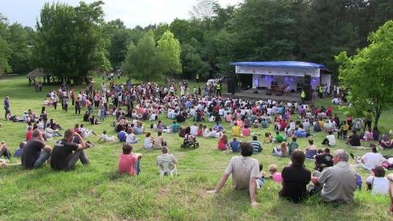
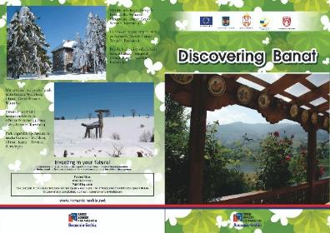

the implementation period (including extensions)
total funds spent/total funds contracted *100
indicators and level of achievement against targets set

