Project information
CALL FOR PROPOSALS | 1
MIS-ETC: | 1265
PRIORITY AXIS: | 1.Economic and Social Development
MEASURE: | 1.1 Support for local/regional economic and social infrastructure
PROJECT TITLE: | Health without borders
ACRONYM: | HWB
DURATION: | 29.12.2012 28.12.2014
IPA FUNDS CONTRACTED: | 1.843.956,00 €
TOTAL FUNDS CONTRACTED: | 2.169.360,00 €
ABSORBTION RATE (%): | 92,67%
PROJECT OBJECTIVE(S): | Improvement of Health Care in the border region linking Požarevac and Resita medical institutions.  Providing quality Health Care through revitalization and equipping of Hospital facilities in border region.  Establishing ca continuous cooperation among Health Care institutions in border region.
SHORT DESCRIPTION OF THE PROJECT: | The focus of the initial efforts of the project was to enable cross-border cooperation through investment in health facilities and equipment and through telemedicine in the border area and to open the option for including all health units in the region in the cross-border network  Serbian partner in revitalized one part the one building of General Hospital in Požarevac. After successful revitalization in the newly adapted building were placed several hospital departments: front office and emergency room, laboratory, pathology and transfusion. County Emergency Hospital Resita procured a medical CT scanner.  Also, a telemedicine network was established between hospitals in Požarevac and Resita which enables them to quickly share experiences and have cross-border consultations, but also to bring innovation to their work. - Multilingual software (English, Romanian and Serbian) for image/data transfer was developed and implemented in General Hospital Požarevac, Health Center Požarevac, Health Center Kucevo, Health Center Žagubica, Health Center Golubac, Health Center Petrovac na Mlavi. Also the network is established with Romanian partner, Charitable Association PRO VITAM, Resita, Permanent Medical Center Bratosin and Bihoi, Bozovici, Permanent Medical Center Anina and the Permanent Medical Center Bocsa.  A short video about the project is available at:  https://www.youtube.com/watch?v=9j8P3hFrVZ8
DEGREE OF ACHIEVEMENT OF INDICATORS: | Indicator value provisioned in the contract Present indicator value % 6= (5)/(3)*100  Output indicators (1) UM (2) Quantity (3) UM (4) Quantity (5)  Improved physical infrastructure in the border area  People in labour force with qualifications received/improved from joint training activities  Result indicators  Increased importance of R&D/Innovation in the border area Number of activities, actions, initiatives focusing on promoting the importance of or dealing directly with R&D/Innovation 10 workshops,5 trainings and 5 round tables organized for training of health care and IT personnel, 1 innovative cross-border network Number of activities, actions, initiatives focusing on promoting the importance of or dealing directly with R&D/Innovation 10 workshops,10 trainings and 10 round tables organized for training of health care and IT personnel, 1 innovative cross-border network 100  Project indicators  Infrastructure transformation of Health Centre Požarevac Adequate facility needed for health care providing 1 Adequate facility needed for health care providing 1 100  Implemented multilingual software for image transmission among health units with new databases pcs 10 pcs 10 100  Number of health care and IT personnel receiving training persons 100 persons 100 100  Modernization of health care units within the network / number of new equipment purchased pcs 1 pcs 1 100  Number of patients receiving improved health services provided by the network persons 150.000 persons 150.000 100
RESULTS ACHIEVED, INCLUDING PHOTOS: | Improved level of health-care in the Romanian-Serbian border region.  Established a cross-border telediagnostic and teleconsultation network.  Institutional cross-border cooperation in the field of health care.  Modernized health units within the network.  In order to achieve the result: "Improved level of health care in the border region" the Health Centre Požarevac was modernized, new IT and medical equipment was installed and the server systems were also installed;  A new software was Installed in General Hospital Požarevac, Health Center Požarevac, Health Center Kucevo, Health Center Žagubica, Health Center Golubac and Health Center Petrovac na Mlavi. Also network is established with Romanian partners, Charitable Association PRO VITAM, Resita, Permanent Medical Center Bratosin and Bihoi, Bozovici, Permanent Medical Center, Anina and Permanent Medical Center, Bocsa.  During the project the website was developed and maintained:  http://novabolnica.net/index.php?lang=en

Partnership information
 |  | COUNTRY | COUNTY/DISTRICT | BUDGET(EURO) | CONTACT DETAILS
LEAD PARTNER: | Health Centre Požarevac (HCP) | Serbia | Branicevo | 1.272.842,00 | Požarevac, Bratstva I Jedinstva street 135  Tel. +38112550111
PARTNER 2: | County Emergency Hospital Resita (CEHR) | Romania | Caras-Severin | 896.518,00 | Resita, Str. Fagarasului nr.18  Tel. + 40 255/227 830
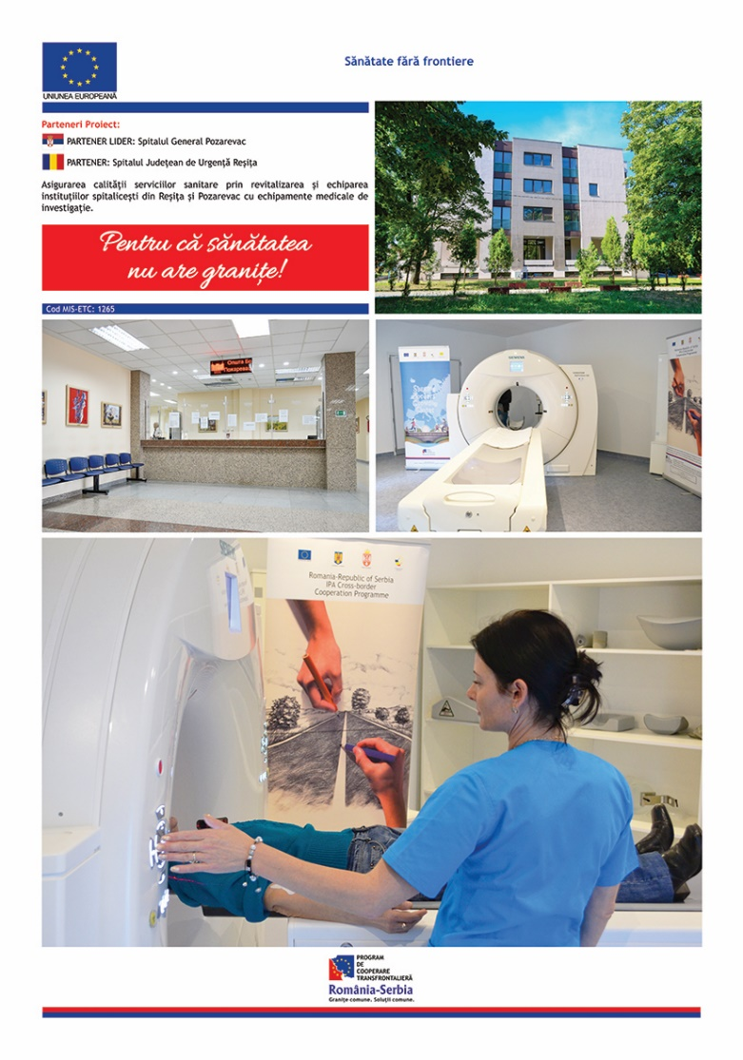

the implementation period (including extensions)
total funds spent/total funds contracted *100
indicators and level of achievement against targets set

