Project information
CALL FOR PROPOSALS | 2
MIS-ETC: | 1256
PRIORITY AXIS: | 2.Environment and Emergency Preparedness
MEASURE: | 2.1 Improve systems and approaches to address cross-border environmental challenges, protection and management
PROJECT TITLE: | Flood prevention - for better life quality
ACRONYM: | Flood EM
DURATION: | 23.01.2014 – 22.04.2016
IPA FUNDS CONTRACTED: | 819.671,15 €
TOTAL FUNDS CONTRACTED: | 964.319,00 €
ABSORBTION RATE (%): | 90,87 %

PROJECT OBJECTIVE(S): | - Improving the quality of life in the cross boarder and Danube area by raising the level of the emergency situations management and preparedness in Resita and Kikinda.  - Increasing technical and human capacities of people involved in the emergency situations field.  - Developing joint planning in emergency situations and dialogue between decision makers.  - Creating cross-border connections among people involved in the emergency situations field.
SHORT DESCRIPTION OF THE PROJECT: | Through implementation of this project the partners purchased emergency intervention equipment; they developed an Emergency Situations Common Strategy, creating cross border connections among people involved in the emergency situations field.

DEGREE OF ACHIEVEMENT OF INDICATORS: | Indicator Indicator value provisioned in the contract Present indicator value % 6= (5)/(3)*100  Output indicators (1) UM (2) Quantity (3) UM (4) Quantity (5)  Increased qualification of human resources in reacting to emergency situations Number of experience exchanges and common drills 4 Number of experience exchanges and common drills 4 100%  Increasing joint planning in emergency situations Number of common strategies regarding emergency situations 1 Number of common strategies regarding emergency situations 1 100%  Increased capacity of municipalities in emergency situations reacting Equipment obtained 12 Equipment obtained 12 100%  Result indicators  Increased institutional capacity and preparedness in reacting to situations of environmental emergency (e.g. flooding, bird flu, swine influenza) action plans or regional cross border strategies 1 action plans or regional cross border strategies 1 100%

RESULTS ACHIEVED, INCLUDING PHOTOS: | - 1 Emergency Situation Common Strategy elaborated;  - 2 common drill organized;  - Emergency intervention equipment procured (1 emergency auto vehicles with high debit moto-pump, 1 emergency auto vehicles with telescopic basket, 1 emergency auto vehicles with water tank, 1 excavator, 5 large capacity tents and 5 inflatable boats);  - 1 Hydraulic excavator and its additional equipment;  -1 Hydraulic excavator attaching drill;  -1 Hydraulic excavator transporting trailer;  -1 Hydraulic excavator grabs for digging attachment;  -1 Hydraulic excavator cropper attachment;  - Revitalized 50 km of canal network in cross border area in municipality of Kikinda area.
Short video about the project | https://www.youtube.com/watch?v=QyreoKbLt8o

Partnership information
 |  | COUNTRY | COUNTY/DISTRICT | BUDGET(EURO) | CONTACT DETAILS
LEAD PARTNER: | MUNICIPALITY OF RESITA | Romania | Caras-Severin | 635.118,00 | Resita, Piata 1 Decembrie 1918, no. 1 A  Tel. 0255/215314
PARTNER 2: | Municipality of Kikinda | Serbia | North Banat | 329.201,00 | Kikinda, Trg srpskih dobrovoljaca 12

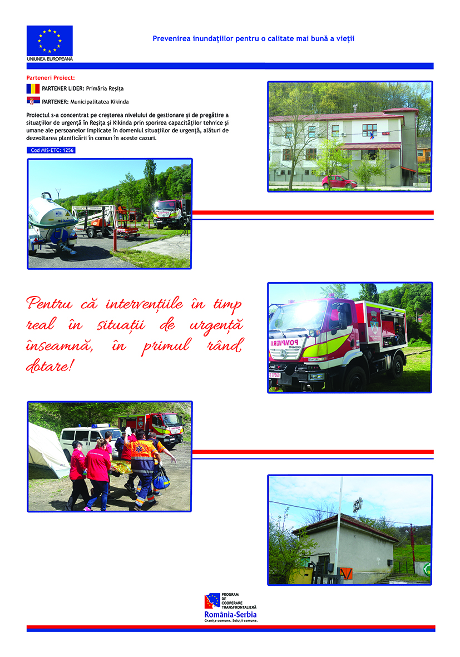

the implementation period (including extensions)
total funds spent/total funds contracted *100
indicators and level of achievement against targets set

