 | Project information
 | CALL FOR PROPOSALS |  | 2
 | MIS-ETC: |  | 1253
 | PRIORITY AXIS: |  | 2.Environment and Emergency Preparedness
 | MEASURE: |  | 2.2 Develop and implement effective strategies for waste and waste water management
 | PROJECT TITLE: |  | Joint strategy for waste water management in the area of Danube hydrological basin
 | ACRONYM:
 | DURATION: |  | 01.01.2016 – 31.12.2016
 | IPA FUNDS CONTRACTED: |  | 481.330,81
 | TOTAL FUNDS CONTRACTED: |  | 566.271,54
 | ABSORBTION RATE (%): |  | 87,41
 | PROJECT OBJECTIVE(S): |  | Improvement of the quality of life for the communities of the border area.  Increasing the number of joint cross-border environmental initiatives.  Raising the population’s interest to preserve the regional environment.
 | SHORT DESCRIPTION OF THE PROJECT: |  | The aim of the project was to elaborate a joint cross-border strategy. Raising the population`s interest to preserve the regional environment was also an important goal, alongside the elaboration of three activity plans concerning waste water management for the improvement of the quality of life: feasibility studies and technical plans for the sewage system for 47 km in Dumbravita Commune (Romania), for 30 km in Giarmata Commune (Romania) and for 55 km in Municipality of Golubac (Serbia).
 | DEGREE OF ACHIEVEMENT OF INDICATORS: |  | Indicator Indicator value provisioned in the contract Present indicator value % 6= (5)/(3)*100  Output indicators (1) UM (2) Quantity (3) UM (4) Quantity (5)  Improved capacity of the cross-border monitoring of environment piece 1 piece 1 100  Improved wastewater treatment in the border area piece 1 piece 1 100  Result indicators  Increased cross-border cooperation in environment protection Number of actions, activities, initiatives protecting the environment 4 number 4 100  Increased public awareness in the field of environment protection Number of participants gained new knowledge in information activities aiming at raising environmental awareness of wider public 270 number 270 100  Project indicators  Initiatives for protection of the Danube hydrological basin number 1 number 1 100  Increasing of joint intervention plans regarding the regional environment number 3 number 3 100  Increasing public awareness concerning waste water number 6 number 6 100
 | RESULTS ACHIEVED: |  | One joint cross-border strategy was elaborated, three activity plans were elaborated concerning waste water management for the improvement of the quality of life (feasibility studies and technical plans for the sewage system for the 47 km in Commune Dumbravita, for 30 km in Commune Giarmata and for 55 km in Municipality of Golubac).  This strategy can be a model for other localities too. In partnership, other localities from the border region can elaborate joint strategies concerning the environment.  All partners raised the population`s interest to preserve the regional environment (achieved through 6 major events organized by the project partners) and distributed flyers concerning the protection of the environment with a special focus on the region`s water network.
Partnership information
 |  |  |  | COUNTRY | COUNTY/DISTRICT | BUDGET(EURO) | CONTACT DETAILS
LEAD PARTNER: |  | Dumbravita Village |  | Romania | Timis | 219.916,50 | Dumbravita, Petofi Sandor, 31  Tel. 004 0256 214 272
PARTNER 2: |  | Municipality of Golubac |  | Serbia | Branicevski | 187.030,00 | Golubac, Cara Lazara 15  Tel. +38112678128
PARTNER 3: |  | Giarmata Village |  | Romania | Timis | 159.325,04 | Giarmata, Str. Principala,  nr. 445  Tel. 0256369101

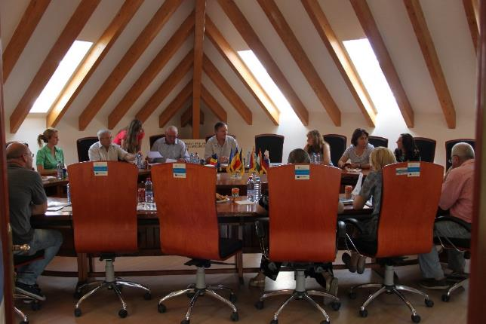
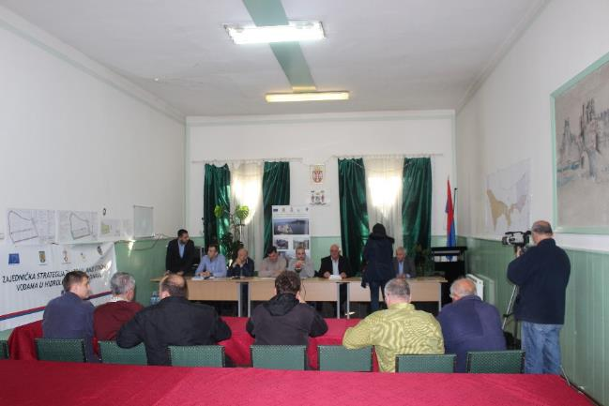
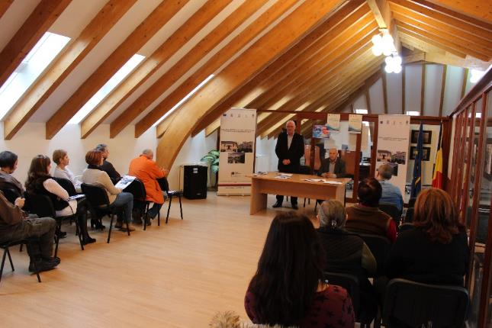
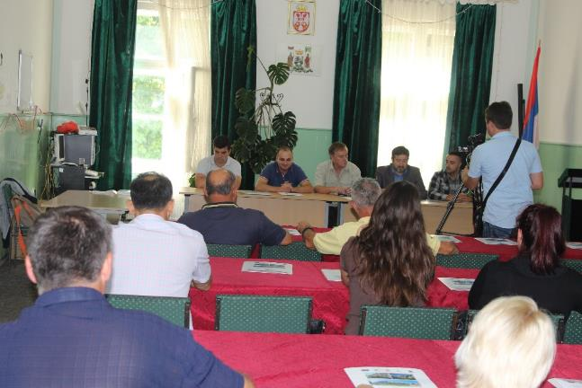

the implementation period (including extensions)
total funds spent/total funds contracted *100
indicators and level of achievement against targets set

