Project information
CALL FOR PROPOSALS | 2
MIS-ETC: | 1251
PRIORITY AXIS: | 3. Promoting “people to people” exchanges
MEASURE: | 3.3 Increase educational, social cultural and sporting exchanges
PROJECT TITLE: | Focus on traditional arts as a means of economic development
ACRONYM: | FocArt
DURATION: | 25.04.2013 -24.04.2014
IPA FUNDS CONTRACTED: | 142.043,84
TOTAL FUNDS CONTRACTED: | 167.110,40
ABSORBTION RATE (%): | 71,59
PROJECT OBJECTIVE(S): | General objective of the project was cross-border cultural cooperation and mutual knowledge, with direct impact on valuing and highlighting the historical and cultural heritage common to the two geographical areas of the project.  Revitalization of the art and local traditional crafts.  Creating opportunities for the population from the Border Region to access quality labour market offers.
SHORT DESCRIPTION OF THE PROJECT: | The common needs established in the two regions showed first of all the need to organize some handcraft workshops for young people in order to avoid losing traditional handcrafts, because there were no organized workshops for the perpetuation of the traditional handcrafts. Considering that for the touristic development in an area, traditional objects are needed, the participants in this project became promoters of the traditional handcrafts. The continuity of traditional handcrafts in the area has been provided by developing three pilot workshops for young people eager to practice traditional handcrafts: one in Resita (Romania), one in Veliko Gradiste (Serbia) and one in Anina (Romania).  Promotion of the handcrafts has been made by using a dedicated web site (www.discoverbanat.eu). The web site included not only the project data, but also the presentation of the existing handcrafts used in the two areas (historic and the contemporary evolution). Also, a film has been made regarding the evolution of the handcrafts. The two fairs organized through the project ensured a good comprehension of the traditional handcrafts.  A short video about the project is available at:  https://www.youtube.com/watch?v=6pbkjgqKX1c
DEGREE OF ACHIEVEMENT OF INDICATORS: | Indicator value provisioned in the contract Present indicator value % 6= (5)/(3)*100  Output indicators (1) UM (2) Quantity (3) UM (4) Quantity (5)  Increased people-to-people exchange in the fields of education and culture  Increase integration of the local community from border area  Result indicators  Increase social and cultural integration of people in the border areas Number of participants benefiting from cross-border social and cultural events Minimum 300 persons Number of participants benefiting from cross-border social and cultural events 300 100  Improved quality of life and increased attractiveness of the border community as a living place Number of activities, actions, initiatives improving educational services 3 Number of activities, actions, initiatives improving educational services 3 100  Project indicators  1 exposition and 2 mini fairs Number of participants benefiting from cross-border social and cultural events Minimum 300 persons Number of participants benefiting from cross-border social and cultural events >300 100  All predicted trainings and workshops conducted 3 training centre established for glass painting, weaving, needlework, pottery. 3 3 training centres established for glass painting, weaving, needlework, pottery. 3 100  3 training cycle in glass painting, weaving, needlework, pottery Minimum 30 participants 3 training cycle in glass painting, weaving, needlework, pottery 40 133  Number of workshops 5 Number of workshops 5 100  Number of participants 250 Number of participants 250 100  2 conference (to start the project and final) Number of participants Minimum 50 Number of participants 52 104  Promotion implemented Number of promotional activities 5 Number of promotional activities 5 100  Flyer promoting 4 representative actions 2800 Pieces Flyer promoting 4 representative actions 2800 100  film 1 film 1 100
RESULTS ACHIEVED, INCLUDING PHOTOS: | Established 3 craft centres (glass painting, knitting, needlework).  Created opportunities for target groups from the Border Region to be entrepreneurs in craft activities.  One film promoting traditional craft activities in the cross-border region was realized and promoted.  Flyer promoting 4 representative actions was made and distributed.  Expositions with representative pictures from the project activities were organized.

Partnership information
 |  | COUNTRY | COUNTY/DISTRICT | BUDGET(EURO) | CONTACT DETAILS
LEAD PARTNER: | ACTIVITY Foundation for human resources and sustainable development | Romania | Caras-Severin | 72.622,40 | Resita, Street Pandurilor No.13  Tel. 0040 255 210532
PARTNER 2: | MUNICIPALITY OF VELIKO GRADISTE | Serbia | BRANICEVSKI | 52.854,80 | VELIKO GRADISTE, ZITNI TRG 1  Tel. +381 12 662 120
PARTNER 3: | City of Moldova Noua | Romania | Caras-Severin | 41.633,20 | Moldova Noua, Nicolae Balcescu street, no.26  Tel. 0 255 540997

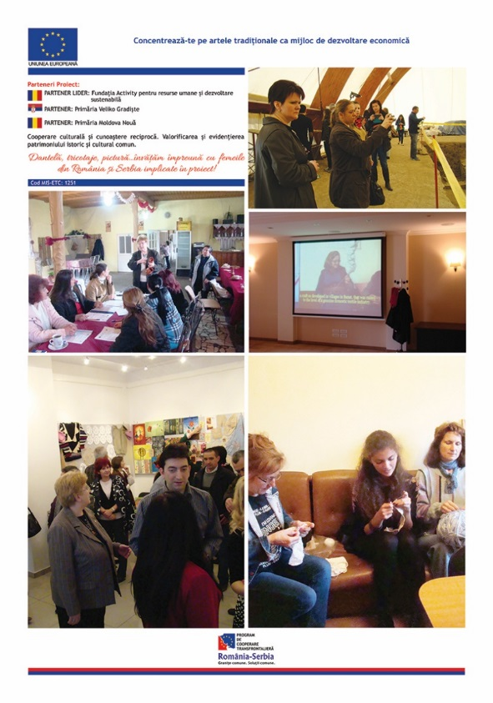

the implementation period (including extensions)
total funds spent/total funds contracted *100
indicators and level of achievement against targets set

