Project information
CALL FOR PROPOSALS | 2
MIS-ETC: | 1246
PRIORITY AXIS: | 3. Promoting “people to people” exchanges
MEASURE: | 3.3 Increase educational, social cultural and sporting exchanges
PROJECT TITLE: | Increasing Educational, Social, and Cultural Exchanges and Recognizing Similarities and Differences Among Young People
ACRONYM: | Different but Similar
DURATION: | 30.04.2013 – 29.04.2014
IPA FUNDS CONTRACTED: | 106.212,60 €
TOTAL FUNDS CONTRACTED: | 124.956,00 €
ABSORBTION RATE (%): | 96,11%
PROJECT OBJECTIVE(S): | General objective was to promote mutual understanding and tolerance by increasing educational, social, and cultural exchanges.  Mutual introduction to the lifestyle of young people on the two sides of the border.  Introduction of the students to literature, geography, important people, and music of the region.  Involving students from disadvantaged groups in psycho drama and helping to solve problems.
SHORT DESCRIPTION OF THE PROJECT: | The project increased education, social, and cultural exchanges between young people in South Banat region in Serbia and Timiş region in Romania. Namely, several groups of students and their teachers conducted research in the region and took part in competitions and in theatre performances.  The project promoted mutual understanding of the people in the two regions, and helped in respecting cultural diversity, promoted innovative solutions for social problems of disadvantages groups of students by spreading already developed good practice in one of the partner school.  The students from the partner schools were organized in groups for visiting, sightseeing and researching similarities and differences between Vršac and Timisoara, for debate, for quiz, for IT support (recording, preparing and editing films, and preparing material for printing), for Psycho drama (elementary school students), for discussion (elementary school students). Also, at the end 6 exhibitions were organized, one Quiz about historical and geographical landmarks of the regions South Banat and Timiş, Debates of high school students about similarities and difference in the social life and Drama performance.
DEGREE OF ACHIEVEMENT OF INDICATORS: | Indicator value provisioned in the contract Present indicator value % 6= (5)/(3)*100  Output indicators (1) UM (2) Quantity (3) UM (4) Quantity (5)  Increased people-to-people exchange in the fields of education, culture and sports  Increased integration of the local communities from border area  Result indicators  Increased social and cultural integration of people in the border areas Number of participants benefiting from cross border social and cultural events >150 students Number of participants benefiting from cross border social and cultural events >150 students 100  >50 teachers >50 teachers 100  >1000 people >1000 people 100  Improved quality of life and increased attractiveness of the border communities as a living place Number of activities, actions, initiatives developing new or improving existing educational and social services, or improving other local living conditions >15 activities Number of activities, actions, initiatives developing new or improving existing educational and social services, or improving other local living conditions >15 activities 100  Improved knowledge of culture, history, society, organizational and institutional structure, and language of the neighbouring country Number of participants gained knew knowledge in events promoting/ profiling the neighbouring country >150 students Number of participants gained knew knowledge in events promoting/ profiling the neighbouring country >150 students 100  >50 teachers >50 teachers 100  >1000 people >1000 people 100  Project indicators  Bulletins with Information Number of Bulletins 5 Number of Bulletins 5 100  Recorded theatre performance Number of recorded performances 1 Number of recorded performances 1 100  Theatre performance Number of theatre performances 1 Number of theatre performances 1 100  Exhibitions Number of exhibitions 4 Number of exhibitions 4 100  Final quiz Number of quiz 1 Number of quiz 1 100  Psycho dramas Number of psycho dramas 2 Number of psycho dramas 2 100  Discussions Number of discussion 2 Number of discussion 2 100  Debates Number of debates 2 Number of debates 2 100  Oratory competition Number of competition 1 Number of competition 1 100
RESULTS ACHIEVED: | 1) Students groups were formed  2) Finished visits to Timisoara and Vršac and material was organized  3) Workshops were held  4) Eliminations for quiz was finished  5) Theatre performance was prepared and held  6) Exhibition was prepared and held  7) Psycho dramas were performed  8) Publication with photos and pictures was prepared and printed  9) Final event was held  10) The theatre performance was organized and held  11) Final quiz was held  12) Project team Meetings was held  13) Bulletins with Information was printed and distributed  14) Video clips on DVD  15) Information and Publicity was finished

Partnership information
 |  | COUNTRY | COUNTY/DISTRICT | BUDGET(EURO) | CONTACT DETAILS
LEAD PARTNER: | Grammar School ”Borislav Petrov Braca” | Serbia | South Banat | 53.335,00 | Vršac, 1 Mihajla Pupina Street  Tel. +381 13 836448
PARTNER 2: | Theoretical Grammar School “Dositej Obradovic” | Romania | Timiş | 27.282,00 | Timisoara, B-dul Dragalina 6  Tel. 0256491624
PARTNER 3: | Elementary School “Mladost” | Serbia | South Banat | 28.986,00 | Vrsac, Omladinski trg, bb  Tel. +381 13 830721
PARTNER 4: | College “Constantin Diaconovici Loga” | Romania | Timis | 15.353,00 | Timisoara, 37 B-dul C. D. Loga  Tel. 0256 491873

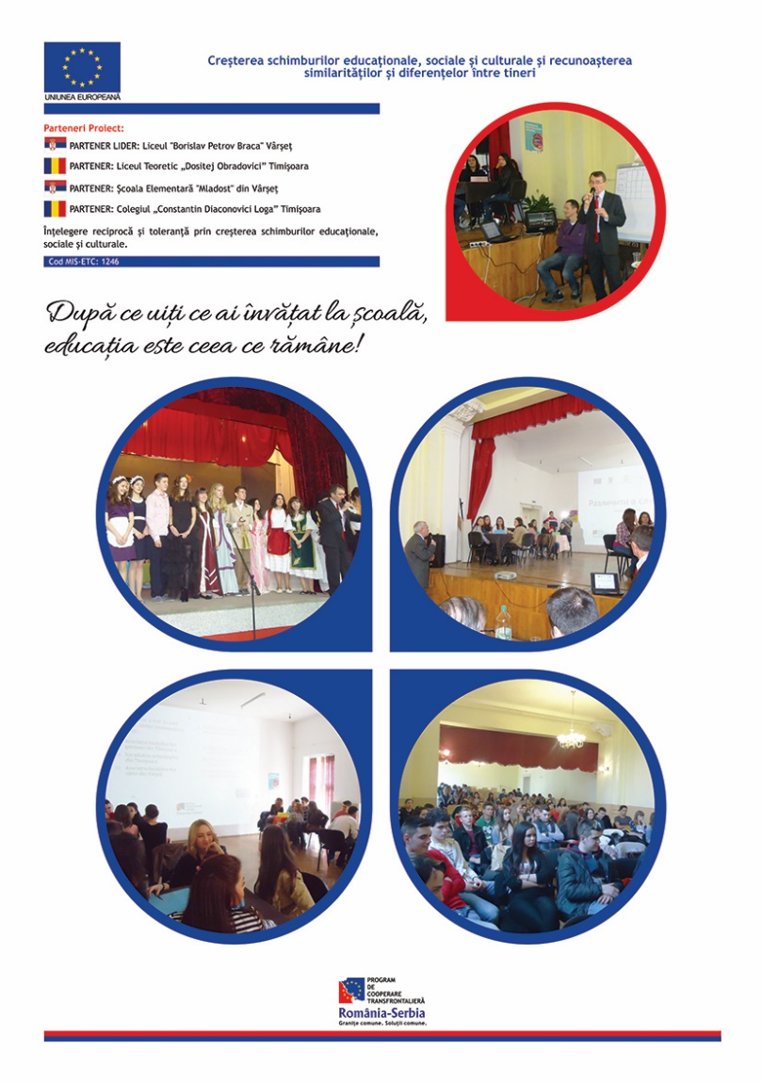

the implementation period (including extensions)
total funds spent/total funds contracted *100
indicators and level of achievement against targets set

