Project information
CALL FOR PROPOSALS | 2
MIS-ETC: | 1238
PRIORITY AXIS: | 3. Promoting “people to people” exchanges
MEASURE: | 3.3 Increase educational, social cultural and sporting exchanges
PROJECT TITLE: | Bridges of culture and traditions
ACRONYM:
DURATION: | 01.01.2016 -31.12.2016
IPA FUNDS CONTRACTED: | 99.874,15 €
TOTAL FUNDS CONTRACTED: | 117.499,00 €
ABSORBTION RATE (%): | 68,21%

PROJECT OBJECTIVE(S): | Promotion of common cultural heritage of areas Moldova Nouă and Majilovac through presentation of inherited customs and traditions, of history of this places.  Promoting the cultural diversity and mutual understanding between different communities/ ethnic groups to benefit from the multiculturality effects and not to create intolerance, racism, discrimination.  Joint capacity building actions for civil society for promoting mutual understanding between neighbours, respect for cultural diversity and innovative solutions for social problems of minorities.
SHORT DESCRIPTION OF THE PROJECT: | This project was focused on the formation of pupils, experience exchanges between 60 pupils and 20 teachers from Moldova Nouă and Majilovac area and cultural exchange between Romanian and Serbian ethnicity.

DEGREE OF ACHIEVEMENT OF INDICATORS: | Indicator Indicator value provisioned in the contract Present indicator value % 6= (5)/(3)*100  Output indicators (1) UM (2) Quantity (3) UM (4) Quantity (5)  Project indicators  Improvement of conditions for study foreign languages in school from Moldova Noua No of equipped offices for Serbian language 1 No of equipped offices for Serbian language 1 100  Improvement of conditions for study foreign languages in school from Majilovac No of equipped offices for Foreign languages 1 No of equipped offices for Foreign languages 1 100  Diversification of extra school activities through setting up of a Serbian folk dance group No of new extra school activities 1 No of new extra school activities 1 100  1 book in two languages No of copies 150 No of copies 150 100  Result indicators  Increased social and cultural integration of people in the border areas Number of participants benefiting from cross-border social and cultural events 60 children 20 teachers Number of participants benefiting from cross-border social and cultural events 60 children 20 teachers 100  Improved knowledge of culture, history, society, organizational and institutional structure, and language of the neighbouring country Number of participants gained knew knowledge in events promoting/profiling the neighbouring country 60 children 20 teachers Number of participants gained knew knowledge in events promoting/profiling the neighboring country 60 children 20 teachers 100
RESULTS ACHIEVED: | 5 meetings were organized between Serbian and Romanian children;  30 children were involved in experience exchanges;  1 office of Serbian language and 1 office for English language were equipped with furniture and computers;  1 sport field covered with synthetic grass, 15 equipment for sports, football and 40 folk costumes were purchased; was set up a dance ensemble.

Partnership information
 |  | COUNTRY | COUNTY/DISTRICT | BUDGET(EURO) | CONTACT DETAILS
LEAD PARTNER: | Industrial School Group Moldova Noua | Romania | Caraş-Severin | 90.435,00 | Moldova Nouă, No. 1, Dunării Street  Tel. 0400 255 540 822
PARTNER 2: | School “Vuk Karađić” Majilovac | Serbia | Braničevski | 27.064,00 | Vuka Karadžića Street, Majilovac  Tel. 0038112674008

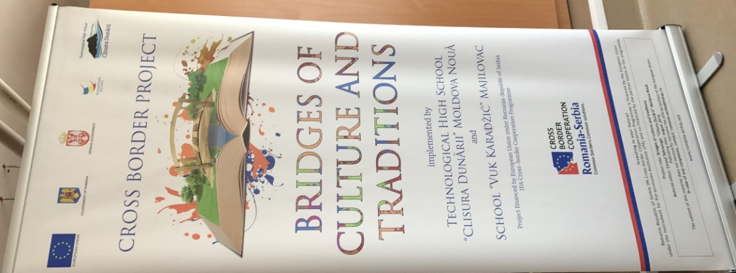
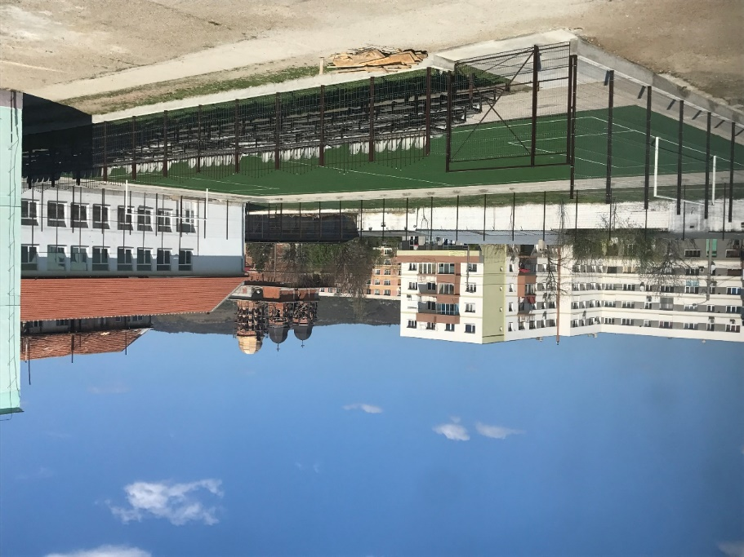
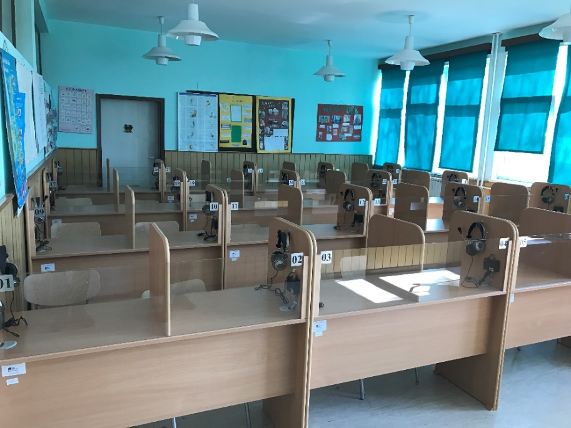

the implementation period (including extensions)
total funds spent/total funds contracted *100
indicators and level of achievement against targets set

