Project information
CALL FOR PROPOSALS | 2
MIS-ETC: | 1236
PRIORITY AXIS: | 1.Economic and Social Development
MEASURE: | 1.2 Develop the tourism sector, including the strengthening of the regional identity of the border region as a tourist destination
PROJECT TITLE: | Imperium Romanum
ACRONYM:
DURATION: | 11.06.2013 – 10.06.2014
IPA FUNDS CONTRACTED: | 274.890,00
TOTAL FUNDS CONTRACTED: | 323.400,00
ABSORBTION RATE (%): | 63,37
PROJECT OBJECTIVE(S): | Tourism development in border region through promotion of cultural and historical heritage from Branicevo region.  Providing tourism signalization in Branicevo and Timis region in order to promote cultural and historical sites.  Strengthening of the regional identity through promotion of historical assets in the border region.
SHORT DESCRIPTION OF THE PROJECT: | The project consisted of organizing 8 mobile exhibitions “If you don’t want to go to the culture, it will come to you” regarding Roman Empire. The exhibitions were organized in Secanj, Coka, Bela Crkva, Majdanpek and Golubac, in Serbia and in Caransebes, Drobeta Turnu Severin, Timisoara and Resita in Romania, one in each border region. Exhibitions in each town were accompanied by actors’ performances regarding Roman Empire traditions. They were dressed in Roman clothes and spoke the texts of the Roman writers about daily life in ancient Rome. Also, a 3D movie regarding Roman empire was presented in the mobile container.  In order to organize these exhibitions partners purchased a mobile container, LCD monitor, IT equipment and necessary furniture and Equipment for 3D presentation.
DEGREE OF ACHIEVEMENT OF INDICATORS: | Indicator value provisioned in the contract Present indicator value % 6= (5)/(3)*100  Output indicators (1) UM (2) Quantity (3) UM (4) Quantity (5)  New or improved cross-border tourism products, joint marketing approaches/ activities or joint tourism information services developed  New or improved cross-border tourism products and services  Result indicators  New or improved cross-border tourism products and services Number of activities, actions, initiatives focusing on promoting tourism in the border area 1 new tourist info point Number of activities, actions, initiatives focusing on promoting tourism in the border area 1 new tourist info point 100  8 exhibitions 8 exhibitions 100  3 3D movies 3 3D movies 100  6 Expert’s seminars 6 Expert’s seminars 100  1 Tourist catalogue 1 Tourist catalogue 100  1 promo concert 1 promo concert 100  1 promo seminar 1 promo seminar 100  8 children’s competitions 8 children’s competitions 100  8 actors’ performances 8 actors’ performances 100  1 set of promotional material 1 set of promotional material 100  1 set of post cards and souvenirs 1 set of post cards and souvenirs 100  Project indicators  Development of new tourist offer Number of exhibitions 8 Number of exhibitions 8 100  Number of seminars 6 Number of seminars 6 100  Number of info points 1 Number of info points 1 100  Promotion of new tourist offer Number of sets of promo material 1 Number of sets of promo material 1 100  Number of 3D movies 3 Number of 3D movies 3 100  Number of promo concerts 1 Number of promo concerts 1 100  Number of actor’s performances 8 Number of actor’s performances 8 100  Number of children’s competitions 8 Number of children’s competitions 8 100  Number of sets of post cards and souvenirs 1 Number of sets of post cards and souvenirs 1 100
RESULTS ACHIEVED: | Mobile exhibitions organized and implemented; wider public getting familiarized with cultural and historical arte facts from border region.  Children’s competition implemented; best works awarded.  3D movies recorded; 3D equipment purchased and 3D presentations implemented.  Actors’ performances implemented; promo concert Music Time Machine organized.  Expert’s seminars and promotion for tourist workers organized.  Margum info point equipped; tourist signalization set up; post cards and souvenirs produced and offered to tourists; catalogue and promo material designed, printed and distributed.

Partnership information
 |  | COUNTRY | COUNTY/DISTRICT | BUDGET(EURO) | CONTACT DETAILS
LEAD PARTNER: | National Muzeum Pozarevac | Serbia | Branicevo | 240.600,00 | Pozarevac, dr Voje Dulica 10  Tel. +381 12 223 597
PARTNER 2: | Caransebes County Museum of Ethnography and Border Regiment | Romania | Timis | 82.800,00 | Piața General Dragalina 2, Caransebeș 325400  Tel. 0040 255 512 193

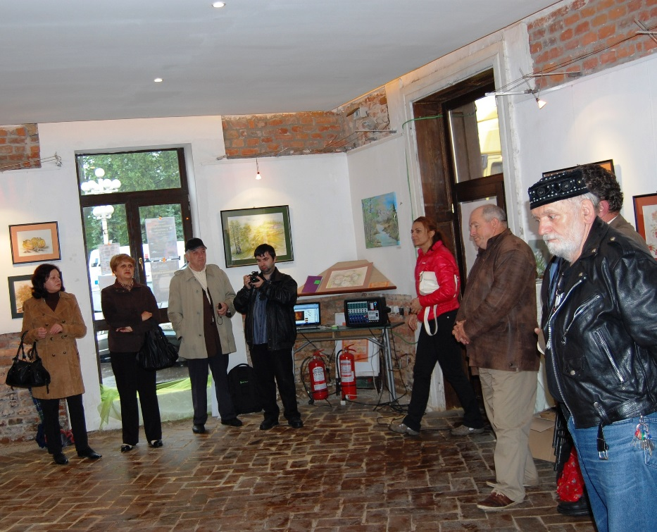
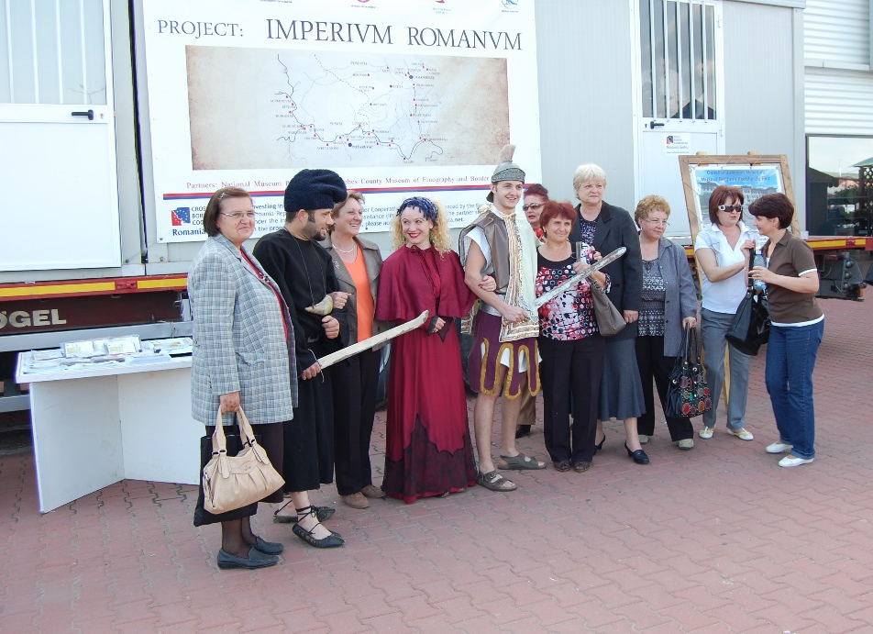

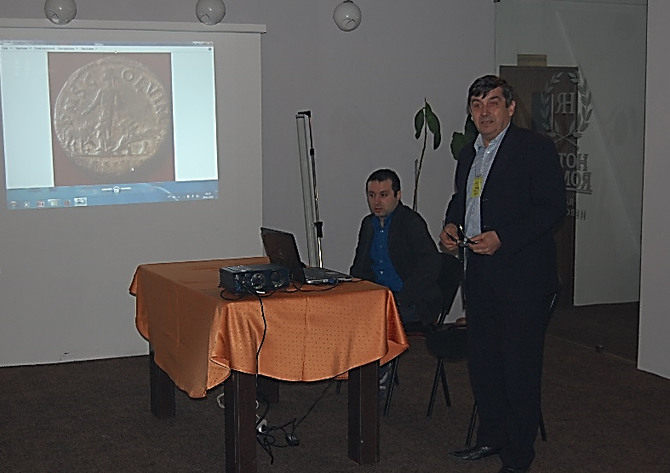
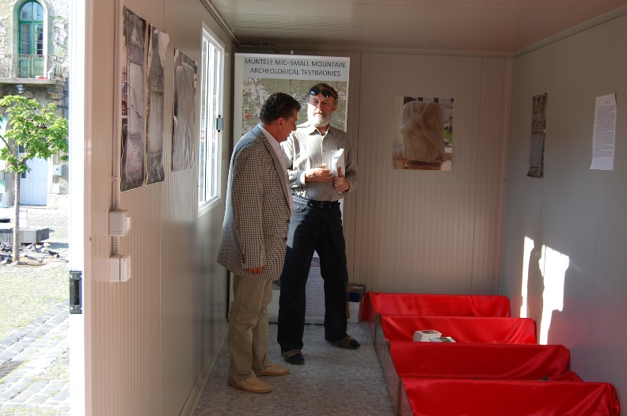

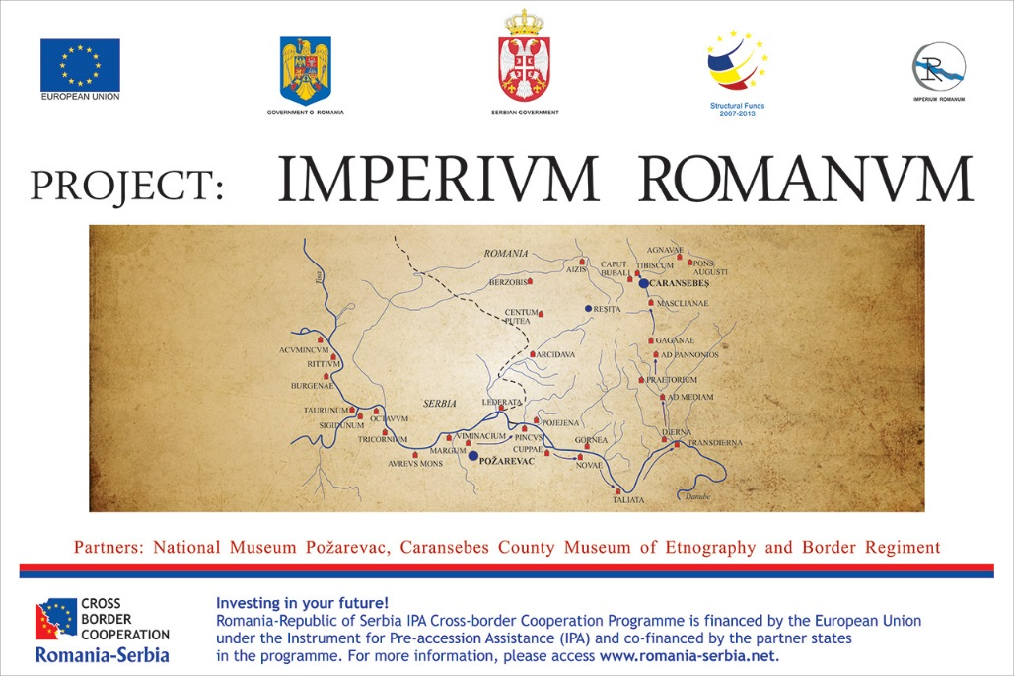
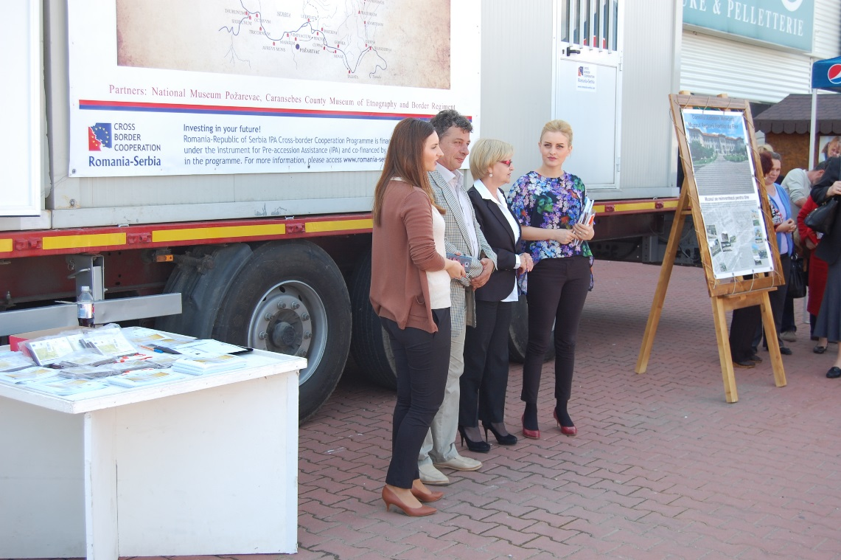
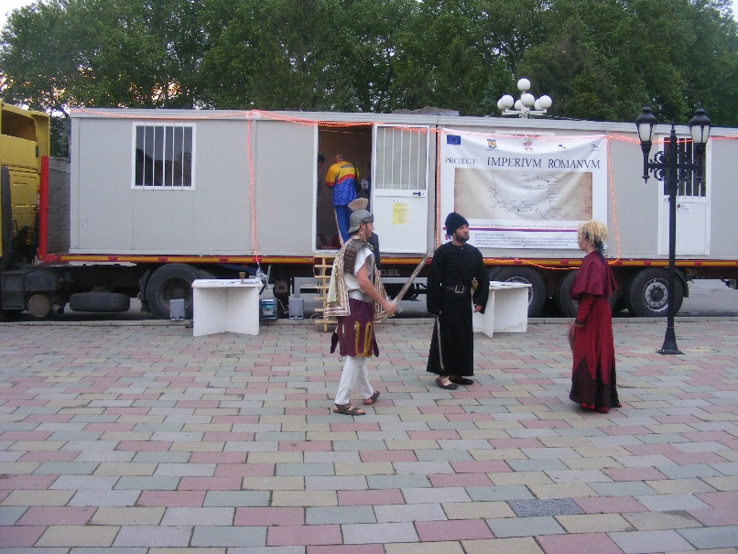

the implementation period (including extensions)
total funds spent/total funds contracted *100
indicators and level of achievement against targets set

