Project information
CALL FOR PROPOSALS | 2
MIS-ETC: | 1233
PRIORITY AXIS: | 1.Economic and Social Development
MEASURE: | 1.4 Support increased levels of R&D and innovation in the border region
PROJECT TITLE: | Improving Sustainability, Competitiveness and Quality of Milk in the Romanian-Republic of Serbia Cross-Border Region
ACRONYM: | SAFEMILK
DURATION: | 01.01.2016 – 31.12.2016
IPA FUNDS CONTRACTED: | 212.366,97€
TOTAL FUNDS CONTRACTED: | 249.843,50€
ABSORBTION RATE (%): | 92,90%

PROJECT OBJECTIVE(S): | Evaluation of the milk quality and its influencing factors in the cross-border region Romania-Republic of Serbia.  Development of a high-specialized centre for milk quality research throughout the acquisition of a state-of-the-art equipment. Development of a training centre for Romanian and Serbian farmers in the field of milk quality and hygiene.
SHORT DESCRIPTION OF THE PROJECT: | Through this project two state of the art centres for research, development and innovation in the dairy sector were developed: one in Caransebes, Romania and one in Zrenjanin, Serbia.  The competitiveness of the dairy sector was improved throughout development of better technical skills of dairy farmers and their knowledge of legal and technical issues, by organizing 6 workshops 2 in Republic of Serbia and 4 in Romania and 4 trainings. Also, 6 scientific articles were published in the Ferma journal.

DEGREE OF ACHIEVEMENT OF INDICATORS: | Indicator Indicator value provisioned in the contract Present indicator value % 6= (5)/(3)*100  Output indicators (1) UM (2) Quantity (3) UM (4) Quantity (5) (6)  Increased importance of R&D/Innovation in the border area Increased importance of R&D/Innovation in the border area - 6 workshops 20-25 people attending/workshop, 120-150 persons/project; Increased importance of R&D/Innovation in the border area - 6 workshops 237 persons attended 158%  - 2 new developed R&D/Innovation centres founded - 2 new developed R&D/Innovation centres founded 100%  Increased SME’s capacity in the border area - Number of trainings 4 trainings, 30-35persons attending / training, 120 - 140 farmers attending Number of trainings 4 trainings 162 persons attended 116%  Project indicators (1) UM (2) Quantity (3) UM (4) Quantity (5) (6)  Acquisition of state-of-the-art equipment’s for R&D centres Number of equipment purchased 9 Number of equipment purchased 9 100%  Level of involvement of the partners in the ongoing of the project Number of meetings 10 Number of meetings 10 100%  Results of the market research in the dairy field Number of farmers, specialist and consumers involved 160 Number of farmers, specialist and consumers involved 291 181.8%  Number of persons benefiting from the information posted on the project’s website Number of persons that visited the website 1300 Number of persons that visited the website 4026 310%  Dissemination of the results from the project to other researchers Number of Scientifically papers published 6 Number of Scientifically papers published 6 100%  Dissemination of the projects results to specialists and milk consumers Number of articles in magazines 4 Number of articles in magazines 10 250%  Dissemination of the projects results to students and dairy farmers Number of brochures edited 500 Number of brochures edited 500 100%  Elaboration and submission of a new research & development project Number of projects submitted to be financed 1 Number of projects submitted to be financed 0 0%  Training of researchers in the milk quality field and related laboratory analysis Number of researchers trained 10 Number of researchers trained 13 130%  Projects publicity for the recruitment of farmers to attend workshops and training sessions Number of flyers printed and delivered 1000 Number of flyers printed and delivered 1000 100%  Number of 4 trainings Persons attending trainings 120-140 Persons attending trainings 162 116%  Number of 6 workshops Persons attending workshops 120-150 Persons attending workshops 237 158%
RESULTS ACHIEVED: | Market research results in the field of raw milk and milk products, through interviews were conducted and questionnaires were filled out by the milk producers and consumers.  Equipment was purchased for better and improved research capacity in the field of milk composition and quality.  IT equipment was purchased for development of a centre for training dairy farmers; the centre was founded in Caransebes, at the premises of Lead Partner.  Improved cohesion between the research & development institutes and the SME (farms, professional associations, farmers and milk processors) was made through 6 workshops and 4 trainings organized.

Partnership information
 |  | COUNTRY | COUNTY/DISTRICT | BUDGET(EURO) | CONTACT DETAILS
LEAD PARTNER: | Sheep and Goats Research & Development Institute Caransebes | Romania | Caras-Severin | 143.260 | Caransebes, Resita Road, km 2  Tel. 0040-255/514189
PARTNER 2: | Veterinary Specialized Institute Zrenjanin | Serbia | Central Banat | 106.583,50 | Zrenjanin, Temisvarski drum 26  Tel. 0038-1605450310

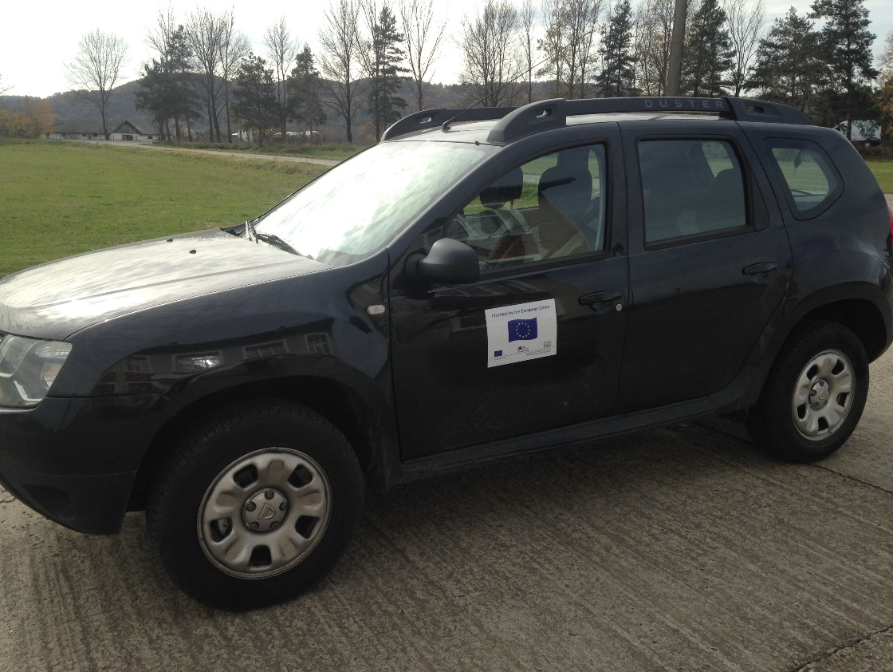
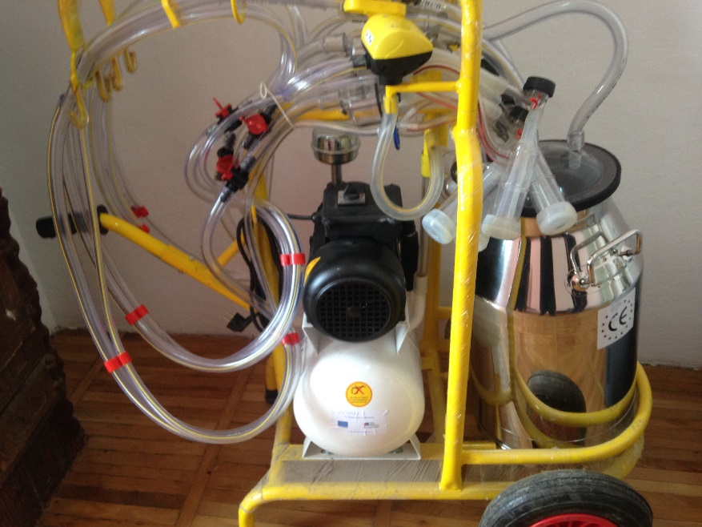
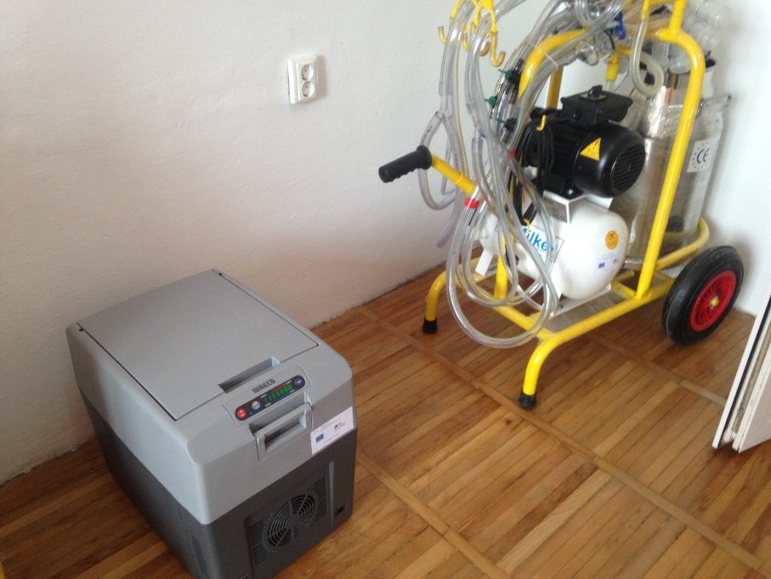

the implementation period (including extensions)
total funds spent/total funds contracted *100
indicators and level of achievement against targets set

